DEACTIVATE SOFTWARE
1, Find the root directory of the DragonCut (Usually in this folder ,as follow )
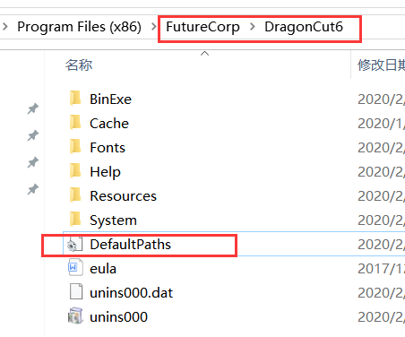

Open the DefaultPaths ( use TXT ) find the PSN , record it .

2 , Open the software , as followed
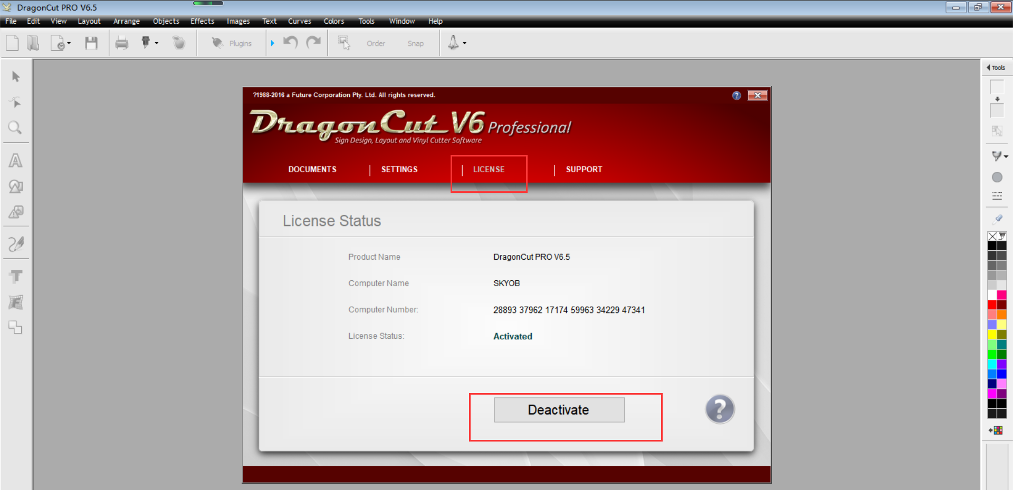
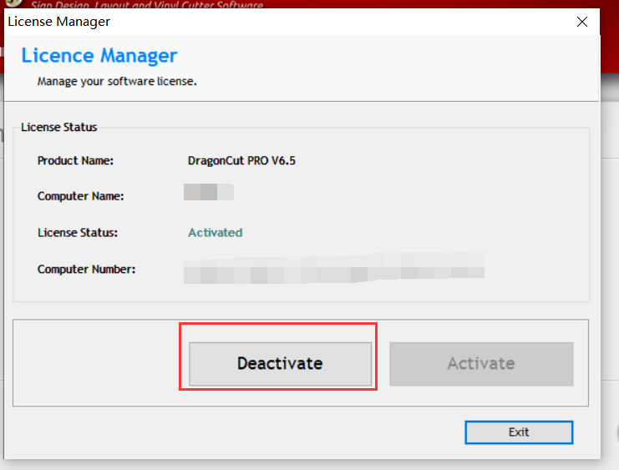
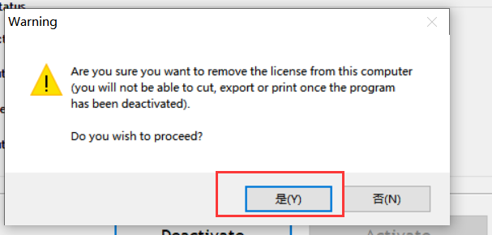

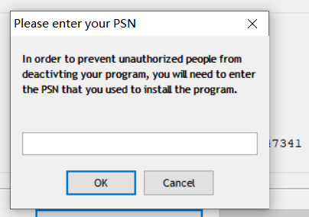
Import the PSN ( the 1st step record) , the software will be deactivated .

