SETUP MANUAL
SHEET CUTTER SG-SC30

01 MACHINE INTRODUCTION OF PRODUCT
02 TOOL TOOL DESCRIPTION
03 SOFTWARE INSTALLATION OF THE PLUGINS
04 OPERATION STEPS AND INSTRUCTION
05 SERVICE SERVICE AND MAINTENANCE

01 MACHINE INTRODUCTION OF PRODUCT
  - Machine parameters
  - Product Introduction
  - Control Panel
  - Standard Parts

1.1Machine parameters
Model | SC30
Force | 10g-500g(10g/step)
Speed | 10mm/s-300mm/s(10mm/s/step)
Max Cutting Depth | 0.20mm
Cutting Material Range  (Paper) | 120g-250g
Non-registration Cutting Area | 330*488mm
Registration Contour Cutting Area | 320*478mm
Mechanical Accuracy | 0.01
Programmable Accuracy | HPGL0.025mm
Control System | Stepper motor
Transmission | USB cable、Net wire/U disk
Software | CorelDRAW plugins
Working Environment | Temperature：+5℃ —  +35℃,41℉—95℉）  Humility：35%—70%RHH（Non-condensing）
Power Supply | 100VAC-240VAC,5/60Hz
Power | 150W
Machine Size
Packing Size
GW/NW

1.2 Product Introduction
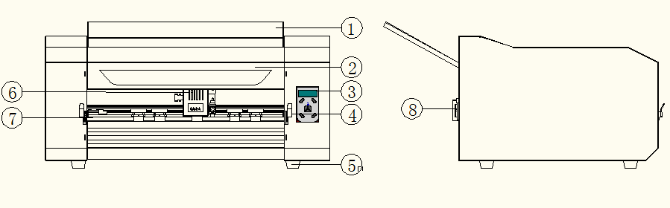
1.Support paper parts:Holding the rear end of paper,especially A3 and A3+ paper.
2.Front cover:Could open the top cover,to observe paper feed status.
3.Control panel:Set the machine parameters and functions.
4.Switch of bar:Change the size of front bar to fit the different widths of materials.Press
the bar out of the hole,the bar will lift up to move the front bar.
5.Stand bottom:Support machine.
6.Carriage:Drives the blade holder or the pen holder to the left or right.
7.Front bar:Attach two bars which could adapt to different materials.
8.The clip of USB line:Fixate the USB cable to prevent it from accidental hitting during work,avoiding the interruption of transmit.
1.3Control Panel
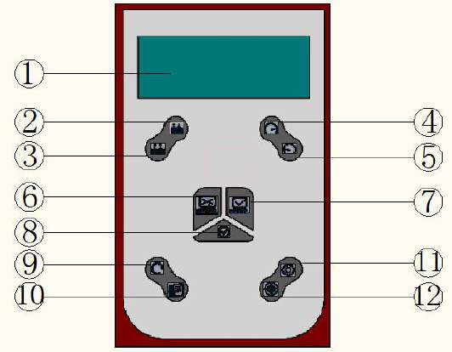
1Screen
2Force increase(Direction key:down key)
3Force decrease(Direction key:up key)
4Speed increase(Direction key:left)
5Speed decrease(Direction key:right)
6Offline
7Online
8Enter
9Reset
10File
11Set
12Test
1.4Standards Parts
Item | Qty | Diagram
Power code | 1 | 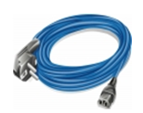
USB cable | 1 | 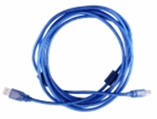
Net wire | 1 | 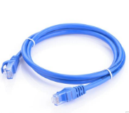
U disk | 1 | 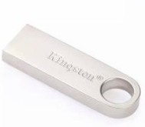
Cutter  holder | 2 | 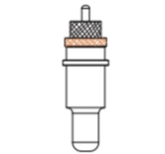
Pen holder | 1 | 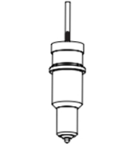
blade | 3 | 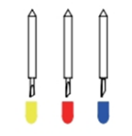
Front bar | 1

02 Tool description
2.1Blade holder introduction
2.2Types of cutter blades
2.3Replacing the blades
2.4Adjust the blade length

2.1Blade holder introduction

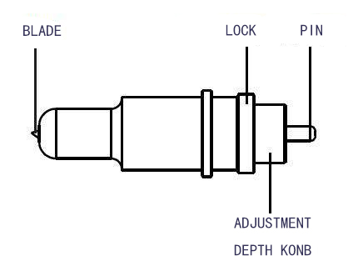
Warning:Be careful of being injured to finger or other parts of body when install the blades.

2.2Blade holder introduction
Name and pic |  | Angle | Blade diameter | Applications and features
Blade |  | 60° | 0.1mm | For thick media and some hard materials.Suit for the thickness between 0.5-1.5mm.
 |  | 45° | 0.1mm | For adhesive stickers or advertising post-it.
 |  | 30° | 0.1mm | For membrane and very soft materials.
Pen holder | 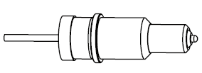 | / | / | Tool of sensor calibrate.

2.3Install blade
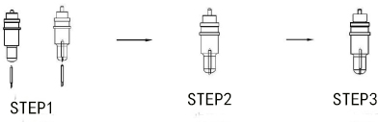
Step1:Put the blade into the tool holder from the bottom.
Step2:Rotate the blade to a proper length with Blade-length adjustment konb,then tighten the Lock.
Step3:Press the Pin and take out of the blade from the top of the blade holder.

Warning:Do not touch the blade tip while remove it.
Notice:The blade is consumable item,please renew one when :
The blade tip has broken.
The blade tip has suffered a lot of wear and tear .The cutting effect are not as good as it were.
The blade will not cut cleanly even though the blade force has been raised significantly.

2.4Adjust the blade length
The blade length can be adjusted by controlling the blade-length Adjusting konb.
To extend the cutter blade,turn the konb in the A direction.
To retract the cutter blade ,turn the konb in the B direction.
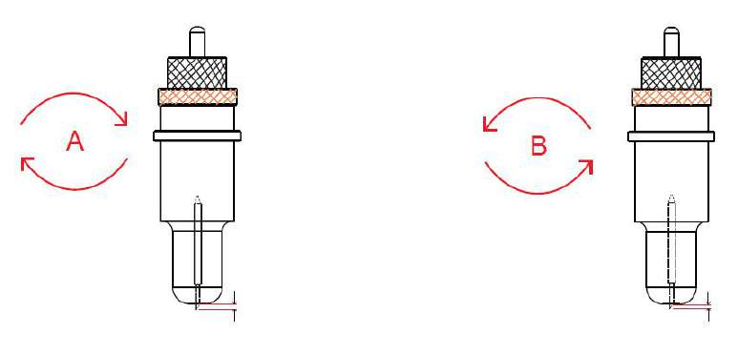
How to confirm the proper blade length:
The length of blade tip usually depends on the materials.You need to adjust the blade tip thinner than the material and thicker than cutting surface.Attention it will go against when the blade tip is too long or short.When adjust the blade tip to a proper length , test it on the the material manually. If the blade cut the cutting surface cleanly and the backing sheet with no damaged,that means the cutting effect is perfect.As below,

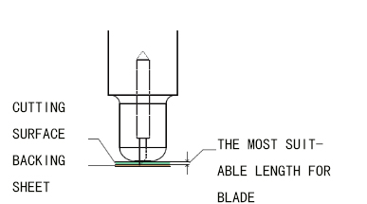

Warning:Be careful to adjust the blade tip.Make sure the blade tip is proper,or it will damage the writing panel and blade.Also the cutting effect will not good if the blade tip is too short.

03Intallation of the software
3.1Install and active
3.2Common parameters of software
3.3How to use plugins

3.1Install and active
Minimum Computer Configuration
·IBM Compatible 1Ghz CPU
·2Gb of available Hard Disk Drive space
·DVDROM
·SVGA color monitor set to a min 1024*768
·256Mb SVGA Video/Graphics card
·2 Mouse
·Microsoft Windows XP(Service Pack 3)
Recommended Computer Configuration
·Intel Quad-Core+
·100GB+of available Hard Disk space
·16GB+of RAM
·DVD Read Write Drive
·Dual24”+Color monitors(1900 Pixels+Wide)
·4.0Gb+Video/Graphics card
·2 Button Scrolling Wheel Mouse
·Sound&Speakers
·Microsoft Windows 7,8 or 10 pro(64 bit)

Please check your CorelDRAW is official edition.Attention the installation of plugins when:
Click the“Saga_SC_Eco_Plugin Add.reg”,install“”
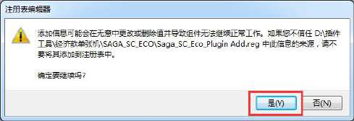
Then click“Saga_SC_Eco_Plugin_x86_RD20200522.exe”,
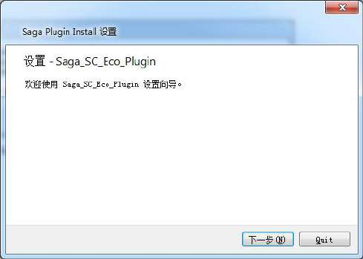
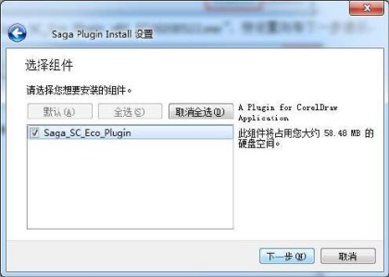
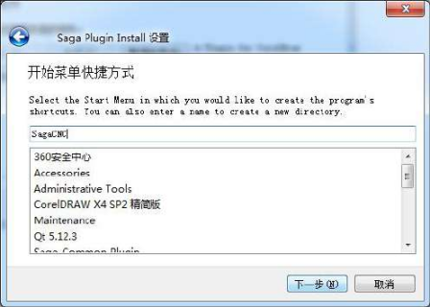
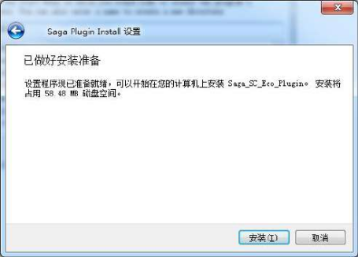
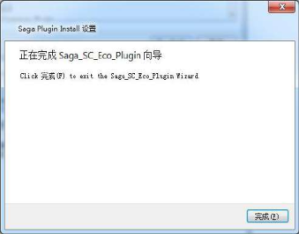
After installing ,open the CorelDRAW,click“application launcher”,open the“saga SC Eco Plugin”
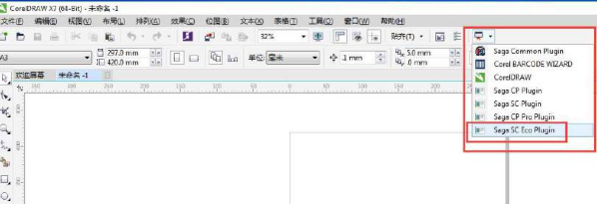

3.2Common function of software

Apply：apply the page mark and in initial page of CorelDRAW
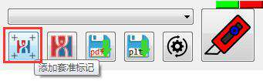
Build :build
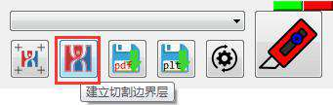
Save as PDF in default
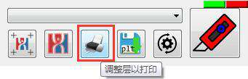
Save as plt:
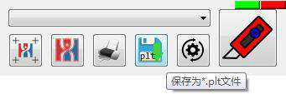

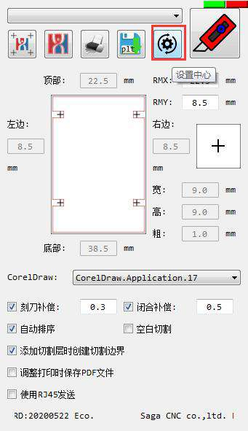
Blade offset:Machine default is 0.3mm,test and modify the blade offset according to the thickness of material.
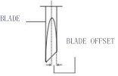

Overcut：Machine default is 2mm,but sometimes need to test and adjust to the overcut according to the thickness of the material.
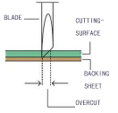
When starting point and ending point did not close,or over closed.Modify this parameter can fixed this problem.Usually,modify this parameter when the thickness of material more than 0.2mm.

3.3How to use the plugins
●Open the CorelDRAW to set the paper size and import label file.
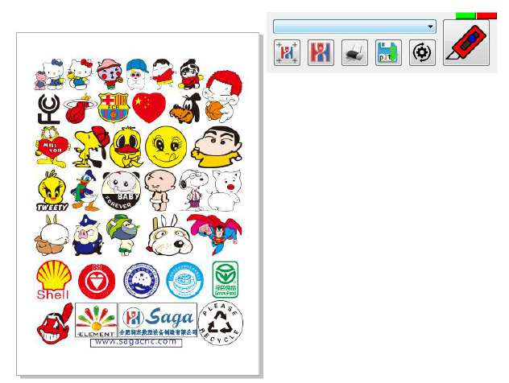
●Open the to default the parameters(CorelDraw version has to use the correct version number.)
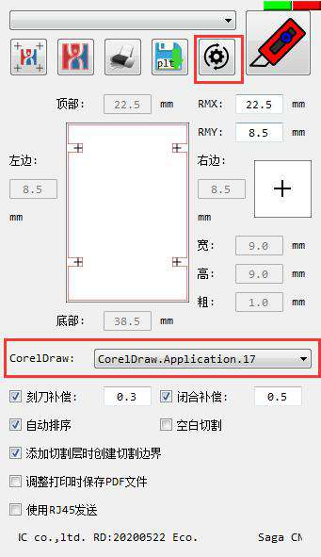
●Click“”to mark for label
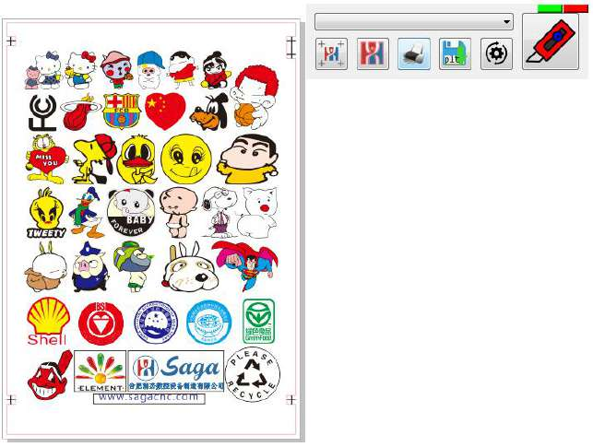
●Click“”to create cutting surface
Click the“”means create cutting surface only ,otherwise,when click“”means outline automatically.
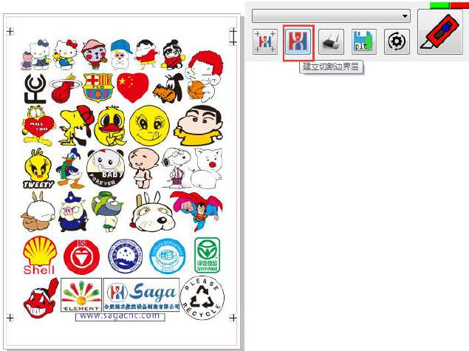
●Click “”to adjust the

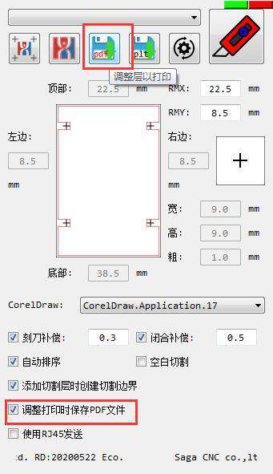
Set the file to the machine
Including two communication ways,the first is:Do not choose“send by RJ45”,the default is USB connect the computer and machine.The second is choose the“send by RJ45”,means of communication is net cable connect the computer and machine.Press the up key and down key on the control panel will occur the IP address,fill it in plugins.Then click the“send to machine”and start to work.
The machine shows IP address.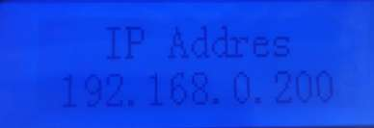
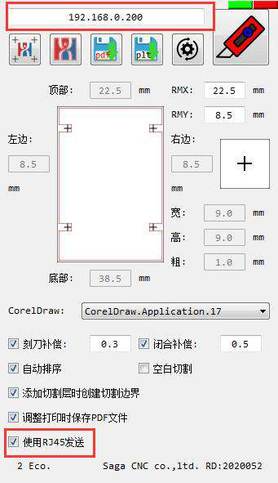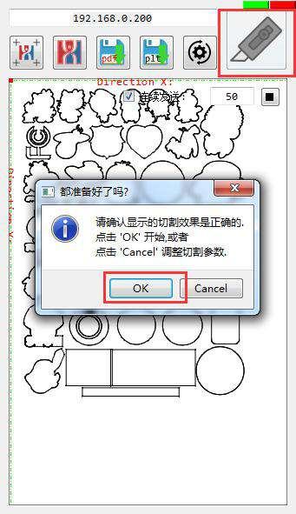
Change the IP address of the local connection into the same network segment with the machine IP at this time.
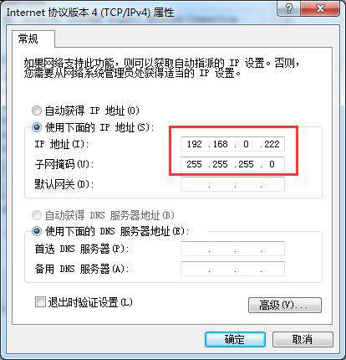
Save the document as PLT cut file.
Click plugins“save as PLT file”,save the file as plt format,copy it to the SD card,
Then the machine start to work after choosing the corresponding file.

04Cutting operation
4.1Basic operational steps
4.2Connecting to computer
4.3Installing tools
4.4Turn on the cutters
4.5Running a cutting test
4.6Loading the media
4.7Sending jobs

4.1Basic operational steps
Install software

Connecting computer with machine

Installing tools(blade/pen)

Turn on the cutter

Cutting test

Loading the media

Working

4.2Connecting to computer
Only install the plugins ,do not need to install any driver.
Operation can not be guaranteed in the following cases:
When connection has been made to a USB hub or an add-on USB board.
When you are using a custom-built computer or one that you have modified.CorelDRAW has not activated by the official version.

Be sure to notice the following:
Do not disconnect the USB cable while switch on the computer or the cutter.
Do not move the carriage by hand after switching on the machine.
Do not disconnect the USB cable within a 5-second period of connecting it.
Do not disconnect the USB cable while data is being transferred.
Do not combine one computer with many machines.
Do not modify parameters during machine is working.
According to the USB user manual,using USB cable to connect the machine with the plugins.You can confirm that whether the USB connection is normal.
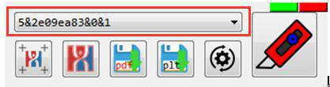

4.3Installing tools
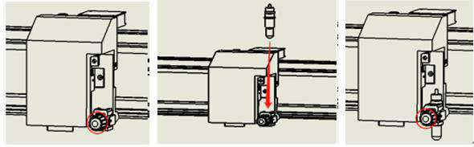
Step1 step2 step3
Step1......Loosen the tool holder screw on carriage.
Step2......Install the blade holder or pen holder into the tool holder on carriage.
Step3......Tighten the tool holder screw.
Warning:When install the blade into the tool holder,avoid being injured by touching blade tip.

4.4Turning on the cutters
1Confirm the voltage,insert the power cable between voltage outlet and machine outlet securely.
2Turn on the power.
3The carriage will back to the origin.The paper will not exit automatically If there are papers into machine.Press the OFFSET key to exit paper or send files directly,the paper will exit automatically to work.

4.5Running a cutting test
Place a A4 or A3 paper in front of the front bar.(Attention the paper direction)
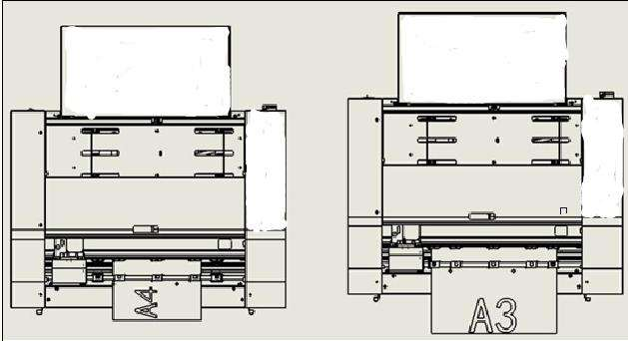
Align the blade into tool holder correctly and adjust the blade tip length.(Please refer to2.4)
Press the control panel,then press“option key”,send the paper to cutting panel,then move the carriage to the center of paper.Press,machine will cut one square and triangle,when cutting over, the paper will be exited a little bit in order to observe the cutting force.If the force is not appropriate,press back to default panel to modify the force parameters.Press again to test the force.The paper will be fed and cut,make sure the modified force is proper.

4.6Loading the media
The way of loading material as below,make sure the paper is flat without folding.
Attention the differences position between A3 and A4 when load the paper.

4.7Sending jobs
Please install your printed media,including barcode and label.
Open the cutting file in Coreldraw plugins and send the cutting command to machine.
Or save the cutting file to U disk,insert the U disk to machine and choose file to cut.It will feed automatically,then scan marks and working.

05SERVICE AND MAINTENANCE
5.1Error messages
5.2Solve the common error
5.3How to replace parts

5.1Error message
Error message
Display error | Reason | Solution
Check paper press entry | The paper tray is empty | Please position the paper correctly  Check the paper weight within the range of 120g-250g.
S1 err press entry | S1 is blocked | S1 is covered by foreign matter .  Check the S1 sensor

5.2Solve the common error
Phenomenon | Cause | Solution
Scan failed | The laser can not scan barcode | Check the print size,print size must the same size as the original file.
 | Check the laser switch | Check whether the laser lines is normal on carriage.
 | The sensor and print size are normal,but can not scan. | Connect the camera to check the injury( Communicate the sales agent about how to connect camera.)
 | The laser and print size are normal,but can not scan. | 1.This material is unsuitable for our machine if the focus length can not be adjust.2.Cutting material is  unevenness.
Unsatisfied cutting effect | The starting point and ending point did not close. | 1.Check the data.2.The offset defaults too low. 3.The material is too flimsy.4.Blade holder did not mount correctly.(Tool holder can be shook easily.）
 | The cutting corners are too round or point. | Modify the OFFSET .If it is too low,the corner would be round,otherwise would be point.
 | Cutting effect is unsatisfied.The surface of material are rough. | 1.Tool holder did not mount correctly,it can be shook easily.2.Force is too low.3.Replace the cutter blade or change another angle blade.4.Check whether the blade can be turned on the tool holder.
 | The blade skipped during cutting,the full line was replaced by dotted line. | 1.Slow it down.2.Adjust the blade length.3.Check whether the blade can be rotated easily on tool holder.
 | Cutting effect deviated | Calibrate the offset value.

5.3How to replace parts
IF you need more information .
Pleas download at www.sagacnc.com.
Or contact our local agent sales.

Thank you for your reference,
if you have any questions,
please contact the local dealer.
Thank you again !
-From saga

