本企业通过ISO9001:2008质量管理体系认证
This company has obtained ISO9001:2008 authentication by Quality Management System

WTZ系列测温仪表使用说明书
Operating Instruction of WTZ Series Thermometric Indicators

专利号 97241538.6
Patent Number 97241538.6
防爆合格证号 CNEx16.3270
Explosion-proof Qualified Number CNEx16.3270
鉴定单位国家防爆电气产品质量监督检验测试中心
Identified by China National Quality Supervision and Test Centre for Explosion Protected Electrical Products (CQST)

南阳市华业防爆仪表有限公司
NanyangHuaye Explosion-proof Instruments Ltd. Co.

- WTZ系列测温仪表概述 Introduction of WTZ Series Thermometric Indicators
新一代液体压力式测温仪表以及由此开发的系列化测温仪表，克服了原仪表性能单一、可靠性差以及温包体积大的缺点，将测温元件体积缩小到原来的1/30至1/60，创造性的将传感器热电阻安装于测温元件内，实现了机电一体化的测温功能。形成了以液体压力式为基本测温仪表的远传、防爆、防震、电接点、温度信号变送等多功能、系列化测温仪表。
The new generation of Liquid Pressure-type Thermometer Indicator and its derivative thermometer indicators series overcome the disadvantages of the last generation, such as single performance, poor reliability and large size of temperature bag, reduce the volume of temperature measurement component to a range from 1/30 to 1/60 of the original one, and creatively install the thermal resistance of sensor into the temperature measurement component to achieve the temperature measurement function of mechanical and electrical integration. They have formed a series of thermometer indicators with the basis of liquid pressure-type thermometer indicators and multi-functions of teletransmission, explosion proofing, shock proofing, electric contact, temperature signal transmitting and so on.

- 型号说明Model Code

W T Z □– 2 8 □ □ / □

A 径向（可省略不注）radial direction (its note can be omitted)
B 万向 universal direction
C 轴向 axial direction
Z 防震 shock proofing
F 防腐 anticorrosion

0 单指示single instruction
8 电接点双上限electric contact with double upper limits
7 电接点单上限electric contact with single upper limit
6 电接点上下限electriccontact with upper and lower limits
5 输出Pt100电阻信号 Pt100 resistance signal output
4 输出热电偶信号 thermocouple signal output
3 输出4-20mA信号4-20mA signal output

图标尺270° Figure Scale 270°
指针式 Pointer Type
普通型（可省略） Ordinary Type (can be omitted)
隔爆型d d Flame-proof Type d
充蒸发液体 Filling Vaporizable Liquid
压力式 Pressure-type
测温仪表 Thermometric Indicator

- 规格于参数Specifications and Parameters
3.1液体压力式系列测温仪表性能一览表
Performance Schedule of Liquid Pressure-type Series of Thermometric Indicators

分类  Classifications | 型号 Models | 名称 Names
普通型  Ordinary Types | WTZ-280（Z） | 液体压力式单指示测温仪表  Liquid Pressure-type Single-instruction Thermometric Indicator
 | WTZ-288 | 液体压力式电接点双上限测温仪表  Liquid Pressure-type Double Upper-limits Electric-contact Thermometric Indicator
 | WTZ-287 | 液体压力式电接点单上限测温仪表  Liquid Pressure-type Single Upper-limit Electric-contact Thermometric Indicator
 | WTZ-286 | 液体压力式电接点上下限测温仪表  Liquid Pressure-type Upper & Lower Limits Electric-contact Thermometric Indicator
 | WTZ-285（Z） | 液体压力式铂热电阻远传测温仪表（防震）  Liquid Pressure-type Platinum Thermistor Teletransmission Thermometric Indicator (Shock Proofing)
 | WTZ-284（Z） | 液体压力式热电偶远传测温仪表（防震）  Liquid Pressure-type Thermocouple Teletransmission Thermometric Indicator (Shock Proofing)
 | WTZ-283（Z） | 液体压力式铂热电阻温度变送器远传测温仪表（防震）  Liquid Pressure-type Platinum Thermistor Temperature TransmitterTeletransmission Thermometric Indicator (Shock Proofing)
隔爆型  Flame-proof Types | WTZd-288 | 液体压力式隔爆型电接点双上限测温仪表  Liquid Pressure-type Flame-proof Double Upper-limits Electric-contact Thermometric Indicator
 | WTZd-287 | 液体压力式隔爆型电接点单上限测温仪表  Liquid Pressure-type Flame-proof Single Upper-limit Electric-contact Thermometric Indicator
 | WTZd-286 | 液体压力式隔爆型电接点上下限测温仪表  Liquid Pressure-type Flame-proof Upper & Lower Limits Electric-contact Thermometric Indicator
 | WTZd-285（Z） | 液体压力式隔爆型铂热电阻远传测温仪表（防震）  Liquid Pressure-type Flame-proof Platinum Thermistor Teletransmission Thermometric Indicator (Shock Proofing)
 | WTZd-284（Z） | 液体压力式隔爆型热电偶远传测温仪表（防震）  Liquid Pressure-type Flame-proof Thermocouple Teletransmission Thermometric Indicator (Shock Proofing)
 | WTZd-283（Z） | 液体压力式隔爆型铂热电阻温度变送器远传测温仪表（防震）  Liquid Pressure-type Flame-proof Platinum Thermistor Temperature TransmitterTeletransmission Thermometric Indicator (Shock Proofing)

3.2基本技术参数Basic Technique Parameters
3.2.1环境温度：-20~45℃，相对湿度小于95%，海拔高度小于2000米。
Environment Temperature: -20~45℃, relative humidity less than 95% and altitude less than 2000m.
3.2.2指示精度：1.5级，2.0级。Indication Accuracy: Level 1.5, Level 2.0
3.2.3热响应时间：34秒。Thermal Response Time: 34 sec.
3.2.4测温范围：0~100℃。Measuring Range：0~100℃
3.2.5绝缘等级F级。Insulation Grade：F
4. 工作原理Operating Principle
4.1WTZ-280液体压力式测温仪表（图一）
WTZ-280 Liquid Pressure-type Thermometer Indicator (Figure 1)
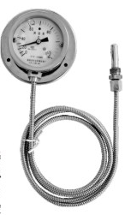
该测温仪表是最基本形式，其他形式都是在此基础上派生出来的，该测温仪表的原理是基于密闭测温系统内蒸发的饱和蒸汽压和温度之间的变化关系，而进行温度测量的。当温包感受到温度变化时，密闭系统内饱和蒸汽压产生相应的压力，引起弹性元件曲率的变化，使其自由端产生位移，再由齿轮放大机构把位移变为指示值，这种测温仪表具有温包体积小、反应速度快、灵敏度高、读数直观等特点，几乎集合了玻璃棒温度计、双金属温度计、气体压力温度计的所有优点，它可以制造成防震、防腐型是目前使用范围最广、性能最全面的一种机械式测温仪表。
This type is the most basic one and other types are all derivative from it. The operating principle of this type is measuring temperature based on the changing relationship between the evaporative saturated vapor pressure and temperature in airtight temperature measurement system. When the temperature bag feels the temperature change, saturated vapor pressure in the airtight system generates a corresponding pressure so as to cause the curvature change of elastic component and displacement of its free end, then the gear amplification mechanism translates this displacement into indicator value. This type is featured with small size of temperature bag, quick response, high sensitivity and direct reading, and nearly collects all the advantages of glass-stem thermometer, bimetal thermometer and gas pressure thermometer. It could be manufactured as shockproof and anti-corrosion types and is one of the mechanical thermometric indicators which are used most widely with the most comprehensive performances at present.
测温部分（温包）的材料：紫铜、紫铜镀铬或1Cr18Ni9Ti。
Material of temperature measuring parts (temperature bag): red copper, red copper plating chromium or 1Cr18Ni9Ti.

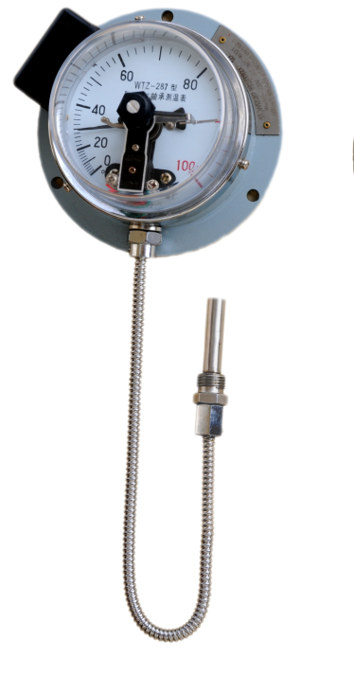
4.2WTZ-288、WTZ-287、WTZ-286电接点测温仪表（图二）
WTZ-288,WTZ-287,WTZ-286 electric contact thermometric indicators (Figure 2)
WTZ-288(287、286)电接点测温仪表是在WTZ-280单指示表的基础上安装了接点装置，通过调节结构，可以方便地改变设定指针的位置，当被测温度上升（或下降）到设定值时，测温仪表会给出一个开或关的信号，用于控制、调节或报警被测温度。
WTZ-288(287,286)electric contact thermometric indicators are the types which install contact devices on the basis of WTZ-280 single indicator. By adjusting the structure, they could change the setting position of pointer easily. When the measuring temperature rises (or falls) to the set values, the thermometric indicators will provide a signal of on or off, in order to control, adjust or alarm the measuring temperature.
此类仪表在选型时，电接点于防震两个功能不能同时具备。
This type could have either electric contact or shock proofing during the model selection.

4.3WTZ-285（284、283）液体压力式铂热电阻远传测温仪表（图四）
WTZ-285（284,283）Liquid Pressure-type Platinum Thermistor Teletransmission Thermometric Indicator （Figure 4）
该种仪表是将铂热电阻测温元件与WTZ液体压力式测温仪表的温包置于同一测温元件内的复合仪表。两个测温系统相互独立，互不影响各自的温度测量和精度。这种仪表的突出优点在于只需要单点测温就可实现双重指示被测温度，其中压力式部分用于现场显示，铂热电阻信号用来远传至控制室，通过二次仪表来显示、控制、调节被测温度，两个测温系统型号监视，提高了温度测量的可靠性和准确性。铂电阻远传接线见图五。
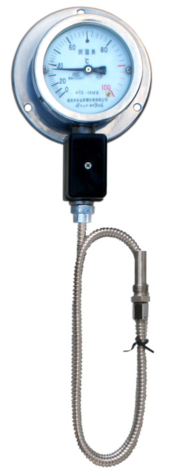
This type is a complex instrument which places the platinum thermistor temperature measurement component and WTZ temperature bag of liquid pressure-typethermometric indicator into a same temperature measurement component. These two temperature measurement systems are independent mutually and will not affect each other’s temperature measurement and accuracy. The outstanding advantage of this type lies in realization of double indication of measuring temperature only at a single temperature measurementpoint, and its pressure-type result is shown in the scene, while the thermistor signal is used for teletransmission to the control room and its measuring temperature is displayed, controlled and adjusted by the secondary instrument. Both temperature measurement systems monitor the results of each other, improving the reliability and accuracy of temperature measurement. Please see the teletransmission wiring of platinum thermistor in Figure 5.

4.4WTZd系列液体压力式隔爆测温仪表
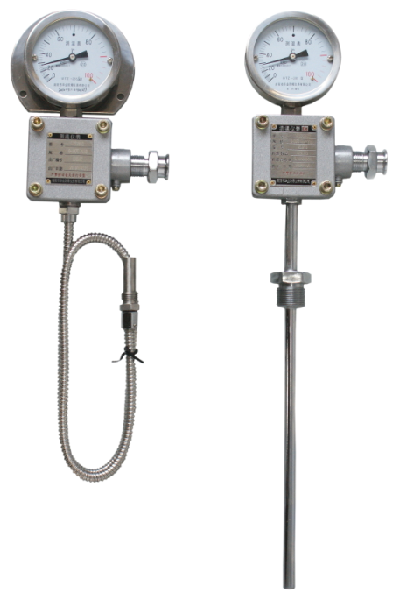
WTZd Series Liquid Pressure-type Flameproof Thermometric Indicator
WTZd系列液体压力式隔爆测温仪表与WTZ系列液体压力式普通测温仪表工作原理相同，不同之处是WTZd仪表外壳采用轻质铝合金或不锈钢，把仪表内可能产生火花、电弧的电路与表壳为爆炸性气体混合物隔开，从而达到隔爆的目的。产品性能符合GB3836-2010《爆炸性气体环境用电气设备第一部分：通用要求》及GB3836.2-2010《爆炸性气体环境用电气设备第二部分：隔爆型“d”》的标准。防爆标志为ExdII B/C T6 Gb。
Theoperating principle of WTZdseries liquid pressure-type flameproof thermometric indicator is same as that of WTZ series liquid pressure-type ordinary thermometric indicator. The distinction is that the former adopts lightweight aluminum alloy or stainless steel to produce its shell, so that it separates the explosive gas mixture from the circuits and watchcase in the indicator which may cause spark and electric arc, in order to achieve the flame-proof. Its product performance meets the standards in GB3836-2010Electrical Equipment in Explosive Gas Environment-Part One General Requirements and GB3836.2-2010Electrical Equipment in Explosive Gas Environment-Part Two Flame-proof Type d. Its explosion-proof sign is ExdIIB/C T6 Gb.

- 结构与固定安装方式Structure and Fixed Installation Types
5.1轴向、径向(表四)Axial and Radial Directions (Table 4)

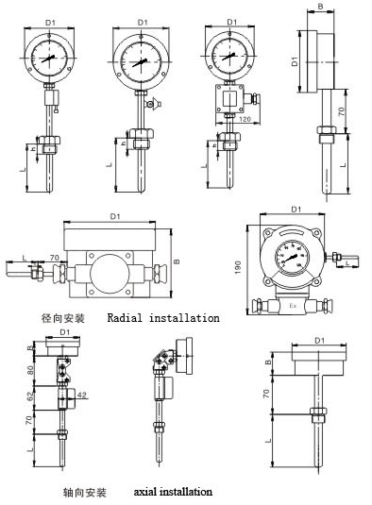
Surface Diameter | Φ80 |  | Φ100 |  | Φ140
表面直径
Boundary Dimension | B | D1 | B | D1 | B | D1
外形尺寸
Model 型号
WTZ-280 | 38 | 85 | 38 | 105
WTZ-283
WTZ-284
WTZ-285
WTZ-286 | 58 | 85 | 58 | 105
WTZ-287
WTZ-288
WTZd-283 | 38 | 85 | 38 | 105
WTZd-284
WTZd-285
WTZd-286 |  |  |  |  | 105 | 150
WTZd-287
WTZd-288
（图中的螺纹、法兰盘尺寸按照国家标准制造）
(The size of screw threads and flanges in the figure are manufactured in accordance with national standard)
5.2挂装式、法兰盘式（表五）Mounting Type, Flange Type (Table 5)
Surface Diameter | Φ80 |  |  | Φ100 |  |  | Φ140
表面直径
Boundary Dimension | B | D1 | D2 | B | D1 | D2 | B | B | D1
外形尺寸
Model 型号
WTZ-280 | 38 | 85 | 100 | 38 | 105 | 120
WTZ-283
WTZ-284
WTZ-285
WTZ-286 | 58 | 85 | 100 | 58 | 105 | 120
WTZ-287
WTZ-288
WTZd-283 | 38 | 85 | 100 | 38 | 105 | 120
WTZd-284
WTZd-285
WTZd-286 |  |  |  |  |  |  | 105 | 150 | 160
WTZd-287
WTZd-288
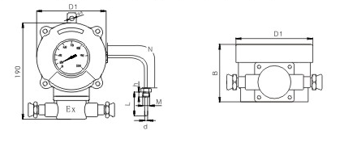
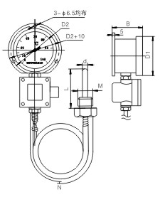
6.使用与维护Operation and Maintenance
6.1检查Inspection
6.1.1安装前先检查仪表与你所选的型号是否一致。
Before installation, please inspect whether the indicator conforms to the model you choose.
6.1.2仪表若已出厂十二个月，请重新校验，合格后方可使用（不具备校验条件的，我公司免费负责复校）。
When the indicator has left factory for twelve months, please reexamine it and use it only when qualified (Our company will reexamine it for free if you don’t have examination conditions)
6.1.3检查仪表的安装尺寸与被测设备上所预留的安装尺寸是否一致。
Check whether the installation dimension of indicator agrees with the reserved installation dimensionin the measured equipment.
6.1.4禁止仪表上所带的安装尺寸与设备上预留的安装尺寸进行配钻，以免强烈的震动而损坏仪表。
Forbid to drill the installation dimension of indicator together with the reserved installation dimensionin the measured equipment, to avoid the damage of the indicator due to strong shock.
6.1.5检查仪表配置的电缆线是否到位。
Check whether the cable of the indicator is in place or not.
6.1.6电接点仪表要检查电接点的工作情况是否正常，接点功率是否符合额定值。
Check whether the electric contact of electric contact indicator operates smoothly and the contact power is in line with the rated value.
6.2安装 Installation
6.2.1在完成6.1的检查后，方可安装。
Install the indicator after all the inspections in 6.1.
6.2.2仪表垂直安装在没有震动的安装板上，并尽可能和温包安装处在同一水平位置，以减少由于静液柱作用所引起的附加误差。
Please install the indicator vertically in the mounting plate without shock and keep it at the same level with the temperature bag as possible, to reduce the additive error caused by hydrostatic column effect.
6.2.3温包必须全部浸入被测介质中（并尽可能使温包插入最大深度，以减少由于温包的安装螺栓散热而引起的误差）。
The temperature bag must be completely sunk in the measured medium (and insert the temperature bag to the maximum depth as possible to reduce the error caused by heat dissipation of mounting bolt of temperature bag.)
6.2.4安装时，毛细管应每相隔不大于300mm的距离用扎头固定起来，毛细管的弯曲半径不应小于50mm。
In the installation, the capillary tube should be fixed up at intervals of no longer than 300mm and its bending radius should not be less than 50mm.
6.2.5安装时软尾过长，可挽圈挂于合适的位置，切勿折角、乱抛，并远离发热设备。
In the case that soft tail is too long when installing, it is allowed to take it in loop and hang in the proper location. Don’t bend it in angles or leave it in a mass, and keep it away from the heat producing appliance.
6.2.6仪表经常工作温度最好在标度范围的1/2—3/4处（蒸汽压力式测温仪表，其精度等级指标度的后2/3部分）。
It is better to maintain the operating temperature of the indicator in the 1/2-3/4 of scale range (keeping in the 2/3 of the precision grade scale for the steam pressure-type thermometric indicator)
6.2.7在任何情况下（无论搬运、安装或使用等），仪表应避免强烈震动、碰撞和冲击等。
Please avoid the indicator to suffer the strong shock, crash and impact in any case (transport, installation and operating and so on).
6.2.8硬尾仪表安装时要拧安装螺丝进行安装，严禁搬动表头安装。
Please install the hard tail indicator by twisting the installation screws, and forbid to install by moving the header.
6.2.9软尾仪表安装时要拧安装螺丝进行安装，严禁拧动压帽进行安装。注意，当安装螺纹为不可动时，应先安装探头，在安装表头部分。测温仪表安装完毕后，严禁在设备上进行焊接操作，以免损坏仪表！
Please install the soft tail indicator by twisting the installation screws, and forbid to install by twisting the pressing caps. Caution: in the case that installation screws are unable to move, please install the probe in the part of installation header first. Forbid to conduct soldering on the devices so as not to damage the indicator.
6.3维护Maintenance
6.3.1仪表使用每间隔十二个月应重新校验一次示值，合格后方可使用，若超出误差范围，需检修或更换新表。
The indicator has to be reexamined about the indicating value every twelve months and could be put in use only when qualified. If the indicating value reaches outside the range of error, please overhaul it or change a new one.
6.3.2不允许对传感器软尾部分有任何的挤压、拉伸，不允许将腐蚀性物质接触软尾管。
Don’t make any extrusion and stretch to the soft tail part of the sensor, and don’t expose the soft tail tube to the corrosive substances.
6.3.3在正常使用过程中，要防止运动物体或工件撞击仪表的表头及软尾部分。
In the process of normal use, please prevent the moving objects or work-piece from impacting the header and soft tail of the indicator.
7.订货须知Ordering Notice
用户订货时应说明一下技术尺寸：The users should provide the technical size when making an order:
7.1温包尺寸及安装螺丝尺寸；Sizes of temperature bag and installation screws
7.2传输距离（测温点与表头之间的距离）；Transmission distance (the distance between the temperature measuring point and header)
7.3表头固定方式及尺寸；Fixed type and size of header
7.4其他特殊要求请说明。Other special requirements

工艺设备先进
Advanced process equipment
技术力量雄厚
Strong technical force
质量实行三包
Three guarantees for product quality
交货及时迅速
Timely Delivery
服务热情周到
Warm and thoughtful service

邮政编码：473000
Zipcode:473000
电话：（0377）61613131 61613132
Tel: （0377）61613131 61613132
传真：（0377）61613132
Fax:（0377）61613132
技术咨询：（0377）61613133
Technical Consulting Hotline:（0377）61613133
地址：河南省南阳市高新区2#工业园3#路中段
Address: In the Middle of No. 3 Road No. 2 Industry Park high-tech Zone Nanyang, Henan Province
网址：Http：//www.huayex.com
Website: Http：//www.huayex.com
E-mail：abc@huayex.com

