QMA
QMA connectors

Series QMA is a quick disconnect version of the SMA connector that offers snap-on mating in a denser package (12.4mm pitch), which allows operation at same electrical performance as SMA up to 6GHz. The QMA connectors also offer a higher packaging density, size equivalent to SMA, which can be rotated 360 degrees after they are mated to improve the flexibility of installations.

Key Performance

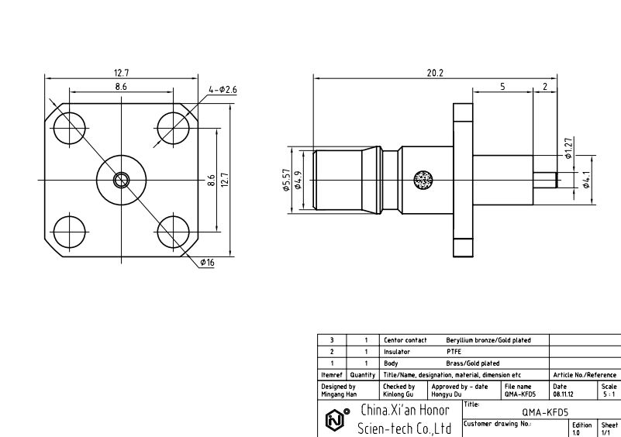
Characteristic Impedance: 50 Ohm
Frequency Range
DC~6GHz (optimized)
DC~18GHz (working range)
VSWR
DC~3GHz: ≤1.06
3~6GHz : ≤1.12
Dielectric Withstanding Voltage: 1500V
Insulation Resistance: ≥5000MΩ
Contact Resistance
Center Conductor: ≤ 3mΩ
Out Conductor: ≤ 2.5mΩ
Temperature Range: -40~+105°C
Durability: 500 cycles

