X1型金属化聚丙烯薄膜交流电容器
Metallized Polypropylene Film AC Capacitor Class-X1

FEATURES
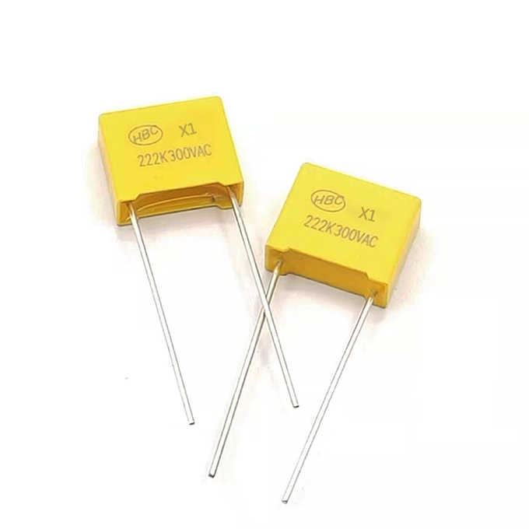
► This specifications cover the requirements of HBC Metallized Polypropylene
► Film AC Capacitor(Interference Suppressors Class-X1)
SPECIFICATIONS

Capacitor Class | "X1”stands for X1 class
Climatic Category | 55/ 105/ 21
Operating Temperature Range | -55 ℃~+105 ℃(for which the capacitor can be operated continuously at rated voltage.
Rated Voltage | 300V.AC,330V.AC 400V.AC 440V.AC
Capacitance Range | 0.0022～4.7μF
Capacitance Tolerance | ±10%
Insulation Resistance(I.R.) | >=15,000 MOhm(C<=0.33μF)  >=5,000 MOhm(C>0.33μF)
Dissipation Factor(DF) | 0.001(0. 1%)max. at 1KHz
DRAWING
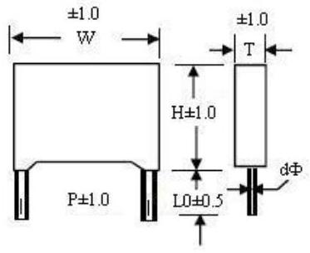
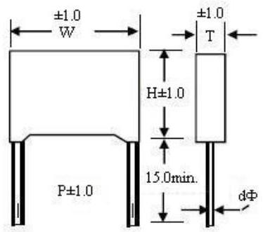
300V.AC STANDARD SIZE (mm)

Mfd | W±1.0 | H±1.0 | T±1.0 | P±1.0 |  | Mfd | W±1.0 | H±1.0 | T±1.0 | P±1.0
0.0022 | 13.0 | 11.0 | 5.0 | 10.0 |  | 0.18 | 26.5 | 17.0 | 8.5 | 22.5
0.0033 | 13.0 | 11.0 | 5.0 | 10.0 |  |  | 18.0 | 18.0 | 10.0 | 15.0
0.0047 | 13.0 | 11.0 | 5.0 | 10.0 |  | 0.2 | 26.5 | 17.0 | 8.5 | 22.5
0.0056 | 13.0 | 11.0 | 5.0 | 10.0 |  | 0.22 | 26.5 | 17.0 | 8.5 | 22.5
0.0068 | 13.0 | 11.0 | 5.0 | 10.0 |  | 0.27 | 26.5 | 19.0 | 10.0 | 22.5
0.0082 | 13.0 | 11.0 | 5.0 | 10.0 |  | 0.33 | 32.0 | 18.0 | 9.0 | 27.5
0.01 | 18.0 | 11.0 | 5.0 | 15.0 |  |  | 26.5 | 19.0 | 10.0 | 22.5
 | 13.0 | 11.0 | 5.0 | 10.0 |  | 0.39 | 32.0 | 18.0 | 9.0 | 27.5
0.012 | 18.0 | 12.0 | 6.0 | 15.0 |  |  | 26.5 | 19.0 | 10.0 | 22.5
 | 13.0 | 11.0 | 5.0 | 10.0 |  | 0.47 | 32.0 | 20.0 | 11.0 | 27.5
0.015 | 18.0 | 12.0 | 6.0 | 15.0 |  |  | 26.5 | 20.0 | 11.5 | 22.5
 | 13.0 | 11.0 | 5.0 | 10.0 |  | 0.56 | 32.0 | 21.5 | 13.0 | 27.5
0.018 | 18.0 | 12.0 | 6.0 | 15.0 |  | 0.68 | 32.0 | 21.5 | 13.0 | 27.5
 | 13.0 | 11.0 | 5.0 | 10.0 |  | 0.82 | 32.0 | 25.5 | 16.0 | 27.5
0.022 | 18.0 | 12.0 | 6.0 | 15.0 |  | 1.0 | 32.0 | 26.0 | 18.0 | 27.5
 | 13.0 | 12.0 | 6.0 | 10.0 |  | 1.2 | 32.0 | 26.0 | 18.0 | 27.5
0.027 | 18.0 | 12.0 | 6.0 | 15.0 |  | 1.5 | 380 | 30.0 | 20.0 | 31.0
 | 13.0 | 12.0 | 6.0 | 10.0 |  | 2.0 | 41.0 | 31.5 | 24.0 | 37.5
0.033 | 18.0 | 12.0 | 6.0 | 15.0 |  | 2.2 | 41.0 | 31.5 | 24.0 | 37.5
0.039 | 18.0 | 12.0 | 6.0 | 15.0 |  | 2.7 | 48 | 32 | 22 | 41
0.047 | 18.0 | 12.0 | 6.0 | 15.0 |  | 3.0 | 48 | 37 | 25 | 41
0.056 | 18.0 | 12.0 | 6.0 | 15.0 |  | 3.3 | 48.0 | 37.0 | 25.0 | 41.0
0.068 | 18.0 | 13.5 | 7.5 | 15.0 |  | 3.9 | 58.0 | 38.0 | 26.0 | 51.0
0.082 | 18.0 | 13.5 | 7.5 | 15.0 |  | 4.7 | 58.0 | 38.0 | 26.0 | 51.0
0.1 | 18.0 | 14.5 | 8.5 | 15.0
0.12 | 18.0 | 14.5 | 8.5 | 15.0
0.15 | 26.5 | 16.5 | 7.0 | 22.5
 | 18.0 | 16.0 | 10.0 | 15.0

Please visit our website to get more update data, those data & specification are subject to change without notice.

Shantou Xin Hua Xiong Electronios Industry Co.,Ltd.
www.cn-huaxiong.com | Tel:【+86】0754-87727171 | QQ:2851010898
E-mail:133269599@qq.com | Fax:【+86】 0754-87728582 | whatsapp:86+15502000092

X1型金属化聚丙烯薄膜交流电容器
Metallized Polypropylene Film AC Capacitor Class-X1
CHARACTERISTICS REFERENCE
Soldering Temperature VS Time

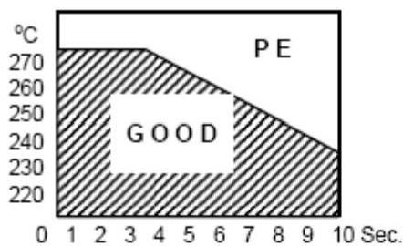
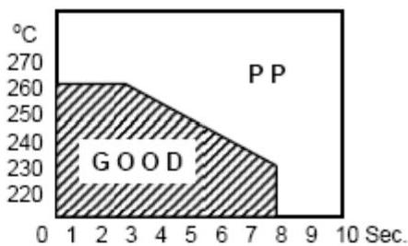

Frequency Characteristics
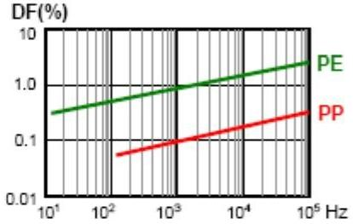
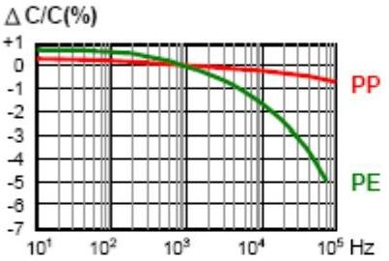

Temperature Characteristics
△C/C(%) at 1KHz
DF(%) at 1KHz
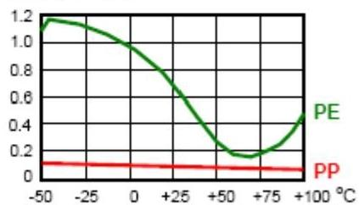
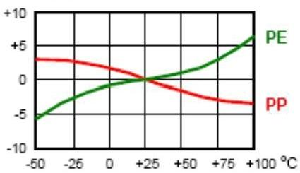

Vn(%)
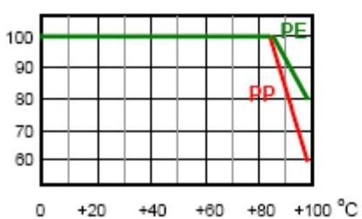

I.R.(MOhm)
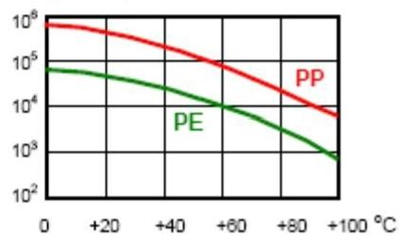

Please visit our website to get more update data, tho se data & specification are subject to change without notice.

Shantou Xin Hua Xiong Electronios Industry Co.,Ltd.
www.cn-huaxiong.com | Tel:【+86】0754-87727171 | QQ:2851010898
E-mail:133269599@qq.com | Fax:【+86】 0754-87728582 | whatsapp:86+15502000092

