金属化聚酯薄膜交流用电容器
Metallized Polyester Film Capacitor(VAC)- CL21(VAC)

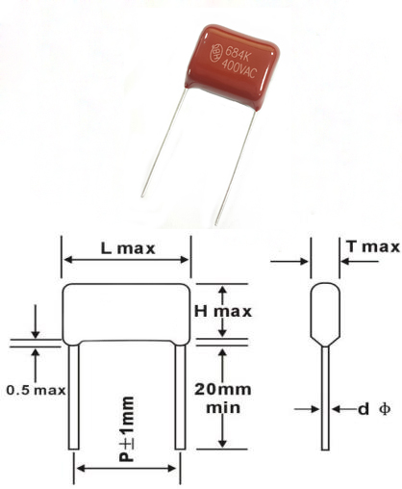
FEATURES
►Non-inductive, coated with epoxy resin or flame retardant epoxy power.
►High capacitance stability.
►High moisture resistance
►High reliability with self-healing performance.
►Recommendable for high frequency circuit use.
►Possibility production of special specification.
►Competitive price.

SPECIFICATIONS
Temperature Range | -40℃~+105℃
Rated Voltage | 250VAC/275VAC/300VAC/400VAC
Capacitance Range | 0.01～1.5 μF
Capacitance Tolerance | ±5%,±10%,±20%
Insulation Resistance | 2,000MΩ
Dissipation Factor | 1% max.(at1KHz)
Dielectric Strength | 175% of rated voltage for 5 sec.
.

STANDARD SIZE(mm)
VAC  Mfd | L | H | T | P | d
0.01 | 13 | 8.5 | 4.2 | 10 | 0.6
0.015 | 13 | 8.8 | 4.8 | 10 | 0.6
0.018 | 13 | 9.3 | 5 | 10 | 0.6
0.022 | 13 | 9.5 | 5.8 | 10 | 0.6
0.027 | 13 | 8.7 | 5.3 | 10 | 0.6
0.033 | 13  18 | 9 | 5.8  5.2 | 10  15 | 0.6  0.8
 |  | 9
0.039 | 13 | 9 | 5 | 10 | 0.6
 | 18 | 9.5 | 6 | 15 | 0.8
0.047 | 13 | 9.5 | 5.5 | 10 | 0.6
 | 18 | 10 | 6.5 | 15 | 0.8
0.056 | 13 | 10.5 | 6 | 10 | 0.6
 | 18 | 11.5 | 6 | 15 | 0.8
0.068 | 13 | 11.4 | 6 | 10 | 0.6
 | 18 | 10.5 | 6 | 15 | 0.8
0.082 | 13 | 11 | 6.2 | 10 | 0.6
0.1 | 13 | 11.8 | 7 | 10 | 0.6
 | 18 | 10.5 | 5.8 | 15 | 0.8
0.15 | 13 | 13.5 | 8 | 10 | 0.6
 | 18 | 12.5 | 6.5 | 15 | 0.8
0.18 | 18 | 13 | 7.0 | 15 | 0.8
0.22 | 18 | 14.5 | 7.5 | 15 | 0.8
0.27 | 18 | 13.5 | 7.6 | 15 | 0.8
0.33 | 18 | 14 | 8 | 15 | 0.8
0.39 | 23 | 14.8 | 9 | 20 | 0.8
0.47 | 23 | 16 | 9.8 | 20 | 0.8
0.56 | 23 | 18 | 10 | 20 | 0.8
0.68 | 23 | 19.5 | 11 | 20 | 0.8
0.82 | 23 | 21 | 11.5 | 20 | 0.8
1.0 | 25 | 21.5 | 12 | 22 | 0.8
1.5 | 31 | 23.5 | 13 | 27 | 0.8
Please visit our website to get more update data, those data & specification are subject to change without notice.
Shantou Xin Hua Xiong Electronios Industry Co.,Ltd.
www.cn-huaxiong.com | Tel:【+86】0754-87727171 | QQ :2851010898
E-mail:133269599@qq.com | Fax:【+86】 0754-87728582 | whatsapp:86+15502000092

