超小型金属化聚酯薄膜电容器
Subminiature size Metallized Polyester Film Capacitor- CL21x min(MEXmin)

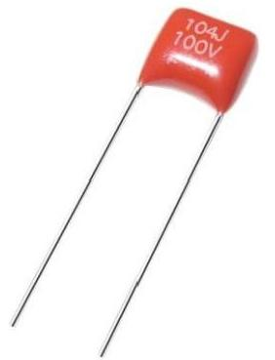
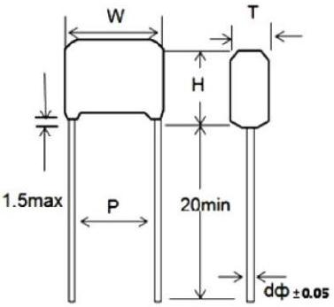

FEATURES
►Non-Inductive
►Epoxy Dip Coated
►Subminiature Size
►RoHS directive compliant

SPECIFICATIONS
Operating Temperature
Climatic Category Rated Voltage
Capacitance Range
Capacitance Tolerance
Voltage Proof
Dissipation Factor
I.R

-55℃~+85℃

55/105/21
50/63/100VDC
0.001μF to 2.2μF
±5%
1.4UR(5s)
≤1%(20 ℃,1KHz)
UR≤100V ≥10000MΩ;CR≤0.33μF
≥2500s;CR>0.33μF(20 ℃,50V,1 min)
UR>100V ≥15000MΩ;CR≤0.33μF
≥5000s;CR>0.33μF(20 ℃,100V,1 min)

.S:T[s]=I.R.[MΩ]*CR[μF]

STANDARD SIZE(mm)
R.V. (50/63/100VDC)
μF | W  (Max) | H  (Max) | T  (Max) | P±1 | d  ±0.05 | μF | W  (Max) | H  (Max) | T  (Max) | P±1 | d  ±0.05
0.001 | 7.5 | 7.0 | 4.0 | 5 | 0.5 | 0.039 | 7.5 | 7.0 | 4.0 | 5 | 0.5
0.0012 | 7.5 | 7.0 | 4.0 | 5 | 0.5 | 0.047 | 7.5 | 7.0 | 4.0 | 5 | 0.5
0.0015 | 7.5 | 7.0 | 4.0 | 5 | 0.5 | 0.056 | 7.5 | 7.0 | 4.0 | 5 | 0.5
0.0018 | 7.5 | 7.0 | 4.0 | 5 | 0.5 | 0.068 | 7.5 | 7.0 | 4.0 | 5 | 0.5
0.0022 | 7.5 | 7.0 | 4.0 | 5 | 0.5 | 0.082 | 7.5 | 7.0 | 4.0 | 5 | 0.5
0.0027 | 7.5 | 7.0 | 4.0 | 5 | 0.5 | 0.1 | 7.5 | 7.5 | 4.5 | 5 | 0.5
0.0033 | 7.5 | 7.0 | 4.0 | 5 | 0.5 | 0.12 | 7.5 | 7.5 | 4.5 | 5 | 0.5
0.0039 | 7.5 | 7.0 | 4.0 | 5 | 0.5 | 0.15 | 7.5 | 7.5 | 4.5 | 5 | 0.5
0.0047 | 7.5 | 7.0 | 4.0 | 5 | 0.5 | 0.18 | 7.5 | 7.5 | 4.5 | 5 | 0.5
0.0056 | 7.5 | 7.0 | 4.0 | 5 | 0.5 | 0.22 | 7.5 | 7.5 | 4.5 | 5 | 0.5
0.0068 | 7.5 | 7.0 | 4.0 | 5 | 0.5 | 0.27 | 7.5 | 8.5 | 4.5 | 5 | 0.5
0.0082 | 7.5 | 7.0 | 4.0 | 5 | 0.5 | 0.33 | 7.5 | 9.0 | 5.0 | 5 | 0.5
0.01 | 7.5 | 7.0 | 4.0 | 5 | 0.5 | 0.39 | 7.5 | 9.0 | 5.0 | 5 | 0.5
0.012 | 7.5 | 7.0 | 4.0 | 5 | 0.5 | 0.47 | 7.5 | 9.5 | 5.5 | 5 | 0.5
0.015 | 7.5 | 7.0 | 4.0 | 5 | 0.5 | 0.56 | 7.5 | 10.5 | 6.0 | 5 | 0.5
0.018 | 7.5 | 7.0 | 4.0 | 5 | 0.5 | 0.68 | 7.5 | 10.5 | 6.5 | 5 | 0.5
0.02 | 7.5 | 7.0 | 4.0 | 5 | 0.5 | 0.82 | 7.5 | 12.0 | 6.5 | 5 | 0.5
0.022 | 7.5 | 7.0 | 4.0 | 5 | 0.5 | 1.0 | 7.5 | 12.0 | 6.5 | 5 | 0.5
0.027 | 7.5 | 7.0 | 4.0 | 5 | 0.5 | 1.5 | 8.2 | 13.5 | 7.5 | 5 | 0.5
0.033 | 7.5 | 7.0 | 4.0 | 5 | 0.5 | 2.2 | 8.2 | 13.5 | 8 | 5 | 0.5
Remark: Pitch 7.5mm also can supply in this series upon request.

Please visit our website to get more update data, those data & specification are subject to change without notice.

Shantou Xin Hua Xiong Electronios Industry Co.,Ltd.
www.cn-huaxiong.com | Tel:【+86】0754-87727171 | QQ :2851010898
E-mail:133269599@qq.com | Fax:【+86】 0754-87728582 | whatsapp:86+15502000092

