盒式金属化聚丙烯薄膜电容器
Box Type Met
Polypropylene Film Capacitor-CBB21B(MPB)

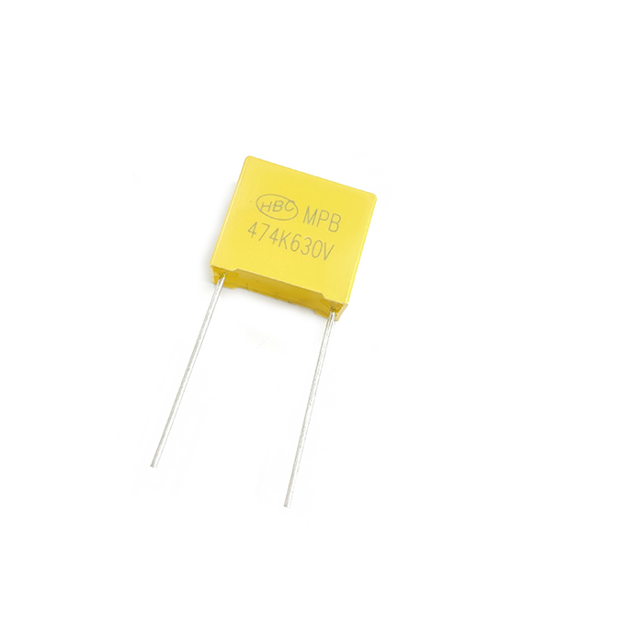

FEATURES

► High reliability at high current stress.
► Self-healing properties.
► Flame retardant plastic case and epoxy resin.
► Low losses, high dv/ dt capability.
► High moisture resistance.
► High stability of capacitance and long life.
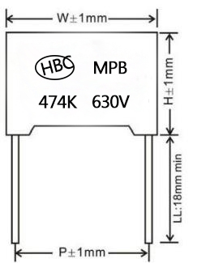
SPECIFICATIONS

Operating Temperature -40℃~+85℃
Rated Voltage 250V,400V,630V.DC

Capacitance Range 0.0047～3.9μF
Capacitance Tolerance ±5%,±10%
Insulation Resistance CR≤0.33μF;IR≥50000MΩ
CR>0.33μF;IR≥15000MΩ
Dissipation Factor 0.1% max. at 1KHz, 20 ℃
Dielectric Strength 160% of rated voltage for 60 se

STANDARD SIZE(mm)
μF | 250VDC |  |  |  |  | 400VDC |  |  |  |  | 630VDC
 | W | H | T | P | d | W | H | T | P | d | W | H | T | P | d
 | ±1.0 | ±1.0 | ±1.0 | ±1.0 | ±0.05 | ±1.0 | ±1.0 | ±1.0 | ±1.0 | ±0.05 | ±1.0 | ±1.0 | ±1.0 | ±1.0 | ±0.05
0.0047 | 13 | 9 | 4 | 10 | 0.6 | 13 | 9 | 4 | 10 | 0.6 | 13 | 9 | 4 | 10 | 0.6
0.0056 | 13 | 9 | 4 | 10 | 0.6 | 13 | 9 | 4 | 10 | 0.6 | 13 | 9 | 4 | 10 | 0.6
0.0068 | 13 | 9 | 4 | 10 | 0.6 | 13 | 9 | 4 | 10 | 0.6 | 13 | 9 | 4 | 10 | 0.6
0.0082 | 13 | 11 | 5 | 10 | 0.6 | 13 | 11 | 5 | 10 | 0.6 | 13 | 11 | 5 | 10 | 0.6
0.01 | 一 | 一 | 一 | 一 | 一 | 一 | 一 | 一 | 一 | 一 | 一 | 一 | 一 | 一 | 一
0.012 | 一 | 一 | 一 | 一 | 一 | 13 | 9 | 4 | 10 | 0.6 | 13 | 11 | 5 | 10 | 0.6
0.015 | 一 | 一 | 一 | 一 | 一 | 13 | 11 | 5 | 10 | 0.6 | 13 | 12 | 6 | 10 | 0.6
0.018 | 一 | 一 | 一 | 一 | 一 | 13 | 11 | 5 | 10 | 0.6 | 13 | 12 | 6 | 10 | 0.6
0.022 | 一 | 一 | 一 | 一 | 一 | 13 | 11 | 5 | 10 | 0.6 | 一 | 一 | 一 | 一 | 一
0.027 | 13 | 11 | 5 | 10 | 0.6 | 13 | 11 | 5 | 10 | 0.6 | 13 | 12 | 6 | 10 | 0.6
0.033 | 13 | 11 | 5 | 10 | 0.6 | 13 | 11 | 5 | 10 | 0.6 | 18 | 11 | 5 | 15 | 0.6
 |  |  |  |  |  | 18 | 11 | 5 | 15
0.039 | 13 | 11 | 5 | 10 | 0.6 | 13 | 11 | 5 | 10 | 0.6 | 一 | 一 | 一 | 一 | 一
 |  |  |  |  |  | 18 | 11 | 5 | 15
0.047 | 13 | 11 | 5 | 10 | 0.6 | 13 | 11 | 5 | 10 | 0.6 | 18 | 11 | 5 | 15 | 0.6
 |  |  |  |  |  | 18 | 11 | 5 | 15 | 0.6
0.056 | 13 | 11 | 5 | 10 | 0.6 | 18 | 11 | 5 | 15 | 0.6 | 18 | 11 | 5 | 15 | 0.6
0.068 | 13 | 11 | 5 | 10 | 0.6 | 18 | 11 | 5 | 15 | 0.6 | 18 | 11 | 5 | 15 | 0.6
 | 18 | 11 | 5 | 15 | 0.6 |  |  |  |  |  | 26.5 | 15 | 6 | 22.5 | 0.8
0.082 | 13 | 12 | 6 | 10 | 0.6 | 18 | 11 | 5 | 15 | 0.6 | 18 | 12 | 6 | 15 | 0.8
 | 18 | 11 | 5 | 15 | 0.6 |  |  |  |  |  | 26.5 | 15 | 6 | 22.5 | 0.8
 | 26.5 | 15 | 6 | 22.5 | 0.6 | 26.5 | 15 | 6 | 22.5 | 0.6 | 26.5 | 22 | 12 | 22.5 | 0.8
Please visit our website to get more update data, those data & specification are subject to change without notice.
Shantou Xin Hua Xiong Electronios Industry Co.,Ltd.
www.cn-huaxiong.com | Tel:【+86】0754-87727171 | QQ :2851010898
E-mail:133269599@qq.com | Fax:【+86】 0754-87728582 | whatsapp:86+15502000092

盒式金属化聚丙烯薄膜电容器
Box Type Met
Polypropylene Film Capacitor-CBB21B(MPB)

STANDARD SIZE(mm)
μF | 250VDC |  |  |  |  | 400VDC |  |  |  |  | 630VDC
 | W | H | T | P | d | W | H | T | P | d | W | H | T | P | d
 | ±1.0 | ±1.0 | ±1.0 | ±1.0 | ±0.05 | ±1.0 | ±1.0 | ±1.0 | ±1.0 | ±0.05 | ±1.0 | ±1.0 | ±1.0 | ±1.0 | ±0.05
0.1 | 13 | 12 | 6 | 10 | 0.6 | 18 | 11 | 5 | 15 | 0.6 | 18 | 12 | 6 | 15 | 0.8
 | 18 | 11 | 5 | 15 | 0.6 |  |  |  |  |  | 26.5 | 15 | 6 | 22.5 | 0.8
0.12 | 18 | 12 | 6 | 15 | 0.8 | 18 | 12 | 6 | 15 | 0.8 | 18 | 13.5 | 8 | 15 | 0.8
 |  |  |  |  |  |  |  |  |  |  | 26.5 | 16 | 7 | 22.5 | 0.8
0.15 | 18 | 12 | 6 | 15 | 0.8 | 18 | 12 | 6 | 15 | 0.8 | 18 | 13.5 | 7.5 | 15 | 0.8
 |  |  |  |  |  |  |  |  |  |  | 26.5 | 17 | 8.5 | 22.5 | 0.8
0.18 | 18 | 12 | 6 | 15 | 0.8 | 18 | 12 | 6 | 15 | 0.8 | 18 | 14.5 | 8.5 | 15 | 0.8
 |  |  |  |  |  | 26.5 | 15 | 6 | 22.5 | 0.8 | 26.5 | 17 | 8.5 | 22.5 | 0.8
 |  |  |  |  |  | 一 | 一 | 一 | 一 | 一 | 32 | 18 | 9 | 27.5 | 0.8
0.22 | 18 | 13.5 | 7.5 | 15 | 0.8 | 18 | 13.5 | 8 | 15 | 0.8 | 18 | 16 | 10 | 15 | 0.8
 | 26.5 | 15 | 6 | 22.5 | 0.8 | 26.5 | 15 | 6 | 22.5 | 0.8 | 26.5 | 19 | 10 | 22.5 | 0.8
 | 一 | 一 | 一 | 一 | 一 |  |  |  |  |  | 32 | 18 | 9 | 27.5 | 0.8
0.27 | 18 | 13.5 | 7.5 | 15 | 0.8 | 18 | 13.5 | 8 | 15 | 0.8 | 18 | 16 | 10 | 15 | 0.8
 | 26.5 | 15 | 6 | 22.5 | 0.8 | 26.5 | 15 | 6 | 22.5 | 0.8 | 26.5 | 22 | 12 | 22.5 | 0.8
 | 一 | 一 | 一 | 一 | 一 | 一 | 一 | 一 | 一 | 一 | 32 | 18 | 9 | 27.5 | 0.8
0.33 | 18 | 14.5 | 9 | 15 | 0.8 | 26.5 | 15 | 6 | 22.5 | 0.8 | 26.5 | 22 | 12 | 22.5 | 0.8
 | 26.5 | 15 | 6 | 22.5 | 0.8 |  |  |  |  |  | 32 | 20 | 11 | 27.5 | 0.8
0.39 | 18 | 16 | 10 | 15 | 0.8 | 26.5 | 17 | 7 | 22.5 | 0.8 | 26.5 | 22 | 12 | 22.5 | 0.8
 | 26.5 | 16 | 7 | 22.5 | 0.8 | 32 | 18 | 9 | 27.5 | 0.8 | 32 | 20 | 11 | 27.5 | 0.8
0.47 | 18 | 14.5 | 8.5 | 15 | 0.8 | 26.5 | 17 | 7 | 22.5 | 0.8 | 26.5 | 19 | 10 | 22.5 | 0.8
 | 26.5 | 16 | 7 | 22.5 | 0.8 | 32 | 18 | 9 | 27.5 | 0.8 | 31.5 | 21.6 | 13 | 27.5 | 0.8
0.56 | 26.5 | 17 | 8.5 | 22.5 | 0.8 | 26.5 | 17 | 8.5 | 22.5 | 0.8 | 31.5 | 21.6 | 13 | 27.5 | 0.8
 |  |  |  |  |  | 32 | 20 | 11 | 27.5 | 0.8
0.68 | 26.5 | 19 | 10 | 22.5 | 0.8 | 26.5 | 19 | 10 | 22.5 | 0.8 | 31 | 25 | 14 | 27.5 | 0.8
 |  |  |  |  |  | 32 | 20 | 11 | 27.5 | 0.8
0.82 | 26.5 | 19 | 10 | 22.5 | 0.8 | 26.5 | 19 | 10 | 22.5 | 0.8 | 一 | 一 | 一 | 一 | 一
 | 32 | 18 | 9 | 27.5 | 0.8 | 32 | 22 | 13 | 27.5 | 0.8 | 一 | 一 | 一 | 一 | 一
1.0 | 26.5 | 22 | 12 | 22.5 | 0.8 | 26.5 | 22 | 12 | 22.5 | 0.8 | 一 | 一 | 一 | 一 | 一
 | 32 | 20 | 11 | 27.5 | 0.8 | 32 | 24.5 | 15 | 27.5 | 0.8 | 一 | 一 | 一 | 一 | 一
1.2 | 32 | 20 | 11 | 27.5 | 0.8 | 32 | 24.5 | 15 | 27.5 | 0.8 | 一 | 一 | 一 | 一 | 一
1.5 | 32 | 22 | 13 | 27.5 | 0.8 | 32 | 22 | 13 | 27.5 | 0.8 | 一 | 一 | 一 | 一 | 一
1.8 | 32 | 22 | 13 | 27.5 | 0.8 | 32 | 33 | 18 | 27.5 | 0.8 | 一 | 一 | 一 | 一 | 一
2.2 | 32 | 22 | 13 | 27.5 | 0.8 | 一 | 一 | 一 | 一 | 一 | 一 | 一 | 一 | 一 | 一
2.7 | 32 | 22 | 13 | 27.5 | 0.8 | 一 | 一 | 一 | 一 | 一 | 一 | 一 | 一 | 一 | 一
3.3 | 32 | 24.5 | 15 | 27.5 | 0.8 | 一 | 一 | 一 | 一 | 一 | 一 | 一 | 一 | 一 | 一
3.9 | 32 | 25.5 | 16 | 27.5 | 0.8 | 一 | 一 | 一 | 一 | 一 | 一 | 一 | 一 | 一 | 一
Please visit our website to get more update data, those data & specification are subject to change without notice.

Shantou Xin Hua Xiong Electronios Industry Co.,Ltd.
www.cn-huaxiong.com | Tel:【+86】0754-87727171 | QQ :2851010898
E-mail:133269599@qq.com | Fax:【+86】 0754-87728582 | whatsapp:86+15502000092

