盒式高压型金属化聚丙烯薄膜电容器
High Voltage Box Type Met Polypropylene Film Capacitor-CBB81B(PSB)

FEATURES
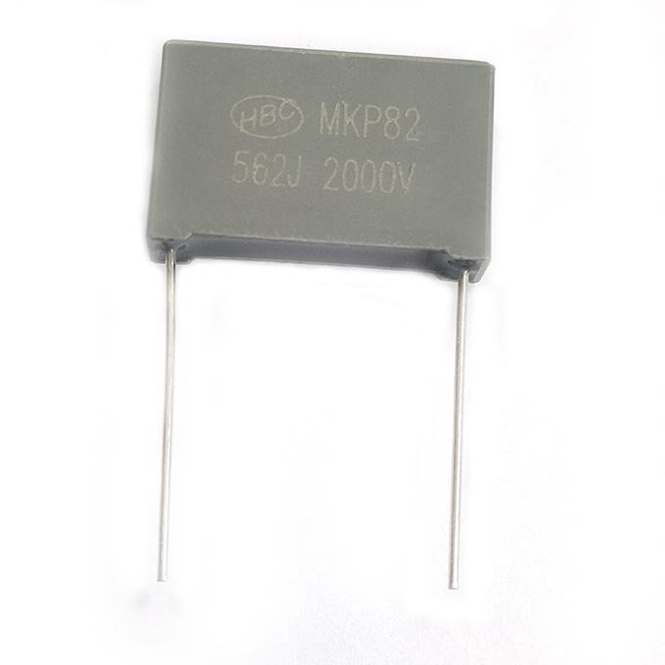
► Metallized structure, widely used in high voltage, high frequency and pulse circuit
► Low loss and small inherent temperature rise
► Negative temperature coefficient of capacitance
► Excellent active and passive flame resistant abilities

SPECIFICATIONS
Reference Standard Climatic Category
Rated Temperature
Operating Temperature Range

Rated Voltage
Capacitance Range
Capacitance Tolerance Voltage Proof
Dissipation Factor

GB14579(IEC 60384-17)
40/105/56
85℃ for UR(DC); 75 ℃ for UR(AC)
-40 ℃~105 ℃(+85 ℃ to +105 ℃ decreasing
factor 1.25% per ℃ for VR DC)
1000V,1400/1600V,2000V
0.00022μF～0.22μF
±2%(G),±3%(E),±5%(J),±10%(K),
±20%(M)
1.6UR(5s)
≤0.001,(20℃,1kHz)

≥50000MΩ,CR≤0.01uF ≥15000s,CR>0.01uF | (20℃,100V,  1min)
Insulation Resistance

OUTLINE DRAWING
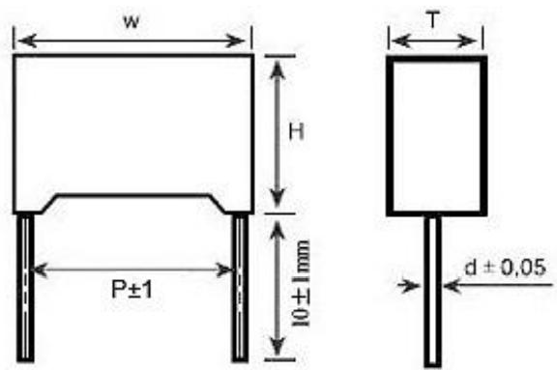
DIMENSIONS(mm)
Lead Pitch:P | ≤10 | >10
Lead Wire Dia.:d±0.05 | 0.6 | 0.8
Dimension Tolerance:W,H,T | W+0.5/-0.7,H±0.5,T±0.5

Shantou Xin Hua Xiong Electronios Industry Co.,Ltd.
www.cn-huaxiong.com | Tel:【+86】0754-87727171 | QQ:2851010898
E-mail:133269599@qq.com | Fax:【+86】 0754-87728582 | whatsapp:86+15502000092
盒式高压型金属化聚丙烯薄膜电容器
High Voltage Box Type Met Polypropylene Film Capacitor-CBB81B(PSB)
STANDARD SIZE(mm)
(μF) | 1000VDC / 1250VDC(600VAC) |  |  |  | 1400VDC/ 1600VDC(650VAC) |  |  |  | 2000VDC(700VAC)
 | P | W | H | T | P | W | H | T | P | W | H | T
0.00022 | 10 | 13 | 11 | 5 | 10 | 13 | 11 | 5 | 15 | 18 | 11 | 5
0.00027 | 10 | 13 | 11 | 5 | 10 | 13 | 11 | 5 | 15 | 18 | 11 | 5
0.00033 | 10 | 13 | 11 | 5 | 15 | 18 | 11 | 5 | 15 | 18 | 11 | 5
 |  |  |  |  | 10 | 13 | 11 | 5
0.00039 | 10 | 13 | 11 | 5 | 10 | 13 | 11 | 5 | 15 | 18 | 11 | 5
0.00047 | 10 | 13 | 11 | 5 | 10 | 13 | 11 | 5 | 15 | 18 | 11 | 5
0.00056 | 10 | 13 | 11 | 5 | 10 | 13 | 11 | 5 | 15 | 18 | 11 | 5
0.00068 | 10 | 13 | 11 | 5 | 10 | 13 | 11 | 5 | 15 | 18 | 11 | 5
 |  |  |  |  | 15 | 18 | 11 | 5
0.00075 | 10 | 13 | 11 | 5 | 10 | 13 | 11 | 5 | 15 | 18 | 11 | 5
0.00082 | 10 | 13 | 11 | 5 | 10 | 13 | 11 | 5 | 15 | 18 | 11 | 5
 |  |  |  |  | 15 | 18 | 11 | 5
0.001 | 15 | 18 | 11 | 5 | 15 | 18 | 11 | 5 | 15 | 18 | 11 | 5
 | 10 | 13 | 11 | 5 | 10 | 13 | 11 | 5 | 22.5 | 26.5 | 15 | 6
0.0012 | 15 | 18 | 12 | 6 | 15 | 18 | 12 | 6 | 15 | 18 | 12 | 6
 | 10 | 13 | 11 | 5 | 10 | 13 | 11 | 5
0.0015 | 15 | 18 | 12 | 6 | 15 | 18 | 12 | 6 | 15 | 18 | 12 | 6
 | 10 | 13 | 11 | 5 | 10 | 13 | 11 | 5
0.0018 | 15 | 18 | 11 | 5 | 15 | 18 | 11 | 5 | 15 | 18 | 12 | 6
 | 10 | 13 | 11 | 5 | 10 | 13 | 12 | 6
0.0022 | 15 | 18 | 12 | 6 | 15 | 18 | 12 | 6 | 15 | 18 | 12 | 6
 | 10 | 13 | 11 | 5 | 10 | 13 | 12 | 6
0.0027 | 15 | 18 | 13.5 | 7.5 | 15 | 18 | 13.5 | 7.5 | 15 | 18 | 14.5 | 8.4
 | 10 | 13 | 11 | 5 | 10 | 13 | 12 | 6
0.0033 | 15 | 18 | 13.5 | 7.5 | 15 | 18 | 13.5 | 7.5 | 15 | 18 | 14.5 | 8.4
 | 10 | 13 | 11 | 5 | 10 | 13 | 12 | 6 | 22.5 | 26.5 | 15 | 6
0.0039 | 10 | 13 | 11 | 5 | 15 | 18 | 14.5 | 8.5 | 15 | 18 | 14.5 | 8.5
 | 15 | 18 | 14.5 | 8.5 |  |  |  |  | 22.5 | 26.5 | 15 | 6
0.0047 | 10 | 13 | 11 | 5 | 15 | 18 | 14.5 | 8.5 | 15 | 18 | 15.5 | 9.5
 | 15 | 18 | 14.5 | 8.5 |  |  |  |  | 22.5 | 26.5 | 15 | 6
0.0056 | 10 | 13 | 11 | 5 | 15 | 18 | 14.5 | 8.5 | 15 | 18 | 14.5 | 8.5
 |  |  |  |  |  |  |  |  | 22.5 | 26.5 | 15 | 6
0.0068 | 10  (1250V) | 13 | 12 | 6 | 15 | 18 | 14.5 | 8.5 | 15 | 18 | 15.5 | 9.5
 | 10  (1000V) | 13 | 11 | 5 |  |  |  |  | 22.5 | 26.5 | 15 | 6
 | 15 | 18 | 14.5 | 8.5
0.0082 | 15 | 18 | 13.5 | 7.5 | 15 | 18 | 14.5 | 8.5 | 15 | 18 | 16 | 10
 |  |  |  |  |  |  |  |  | 22.5 | 26.5 | 15 | 6

Shantou Xin Hua Xiong Electronios Industry Co.,Ltd.
www.cn-huaxiong.com | Tel:【+86】0754-87727171 | QQ:2851010898
E-mail:133269599@qq.com | Fax:【+86】 0754-87728582 | whatsapp:86+15502000092

盒式高压型金属化聚丙烯薄膜电容器
High Voltage Box Type Met Polypropylene Film Capacitor-CBB81B(PSB)

STANDARD SIZE(mm)
(uF) | 1000VDC / 1250VDC(600VAC) |  |  |  | 1400VDC/1600VDC(650VAC) |  |  |  | 2000VDC(700VAC)
 | P | W | H | T | P | W | H | T | P | W | H | T
0.01 | 15 | 18 | 12 | 6 | 15 | 18 | 14.5 | 8.5 | 15 | 18 | 19 | 11
 |  |  |  |  |  |  |  |  | 22.5 | 26.5 | 16.5 | 7
0.012 | 15 | 18 | 12 | 6 | 15 | 18 | 14.5 | 8.5 | 22.5 | 26.5 | 16.5 | 7
0.015 | 15 | 18 | 12 | 6 | 22.5 | 26.5 | 16.5 | 7 | 22.5 | 26.5 | 17 | 8.5
0.018 | 15 | 18 | 13.5 | 7.5 | 22.5 | 26.5 | 17 | 8.5 | 22.5 | 26.5 | 17 | 8.5
0.022 | 15 | 18 | 13.5 | 7.5 | 15 | 18 | 19 | 11 | 22.5 | 26.5 | 19 | 10
 |  |  |  |  | 22.5 | 26.5 | 19 | 10 | 27.5 | 31.4 | 19.5 | 10.8
0.027 | 15 | 18 | 14.5 | 8.5 | 22.5 | 26 | 20 | 11 | 27.5 | 31.4 | 19.5 | 10.8
 | 22.5 | 26.5 | 15 | 6
0.033 | 15 | 18 | 14.5 | 8.5 | 22.5 | 26 | 21.5 | 12 | 22.5 | 26 | 21.5 | 12
 | 22.5 | 26.5 | 15 | 6 |  |  |  |  | 27.5 | 31.4 | 19.5 | 10.8
0.039 | 15 | 18 | 16 | 10 | 27.5 | 31.4 | 19.5 | 10.8 | 27.5 | 31.5 | 21.6 | 13
 | 22.5 | 26.5 | 16.5 | 7
0.047 | 15 | 18 | 19 | 10.8 | 27.5 | 31.4 | 19.5 | 10.8 | 27.5 | 31 | 25 | 14
 | 22.5 | 26.5 | 16.5 | 7
0.056 | 22.5 | 26.5 | 17 | 8.5 | 27.5 | 31.4 | 19.5 | 10.8
0.068 | 22.5 | 26.5 | 17 | 8.5 | 27.5 | 31.5 | 21.6 | 13
0.082 | 22.5 | 26.5 | 19 | 10 | 27.5 | 31.5 | 21.6 | 13
0.1 | 22.5 | 26.5 | 19 | 10 | 27.5 | 31.5 | 21.6 | 13
 | 27.5 | 31.4 | 19.5 | 10.8
0.12 | 27.5 | 31.4 | 19.5 | 10.8
0.15 | 27.5 | 31.4 | 19.5 | 10.8
0.18 | 27.5 | 31.5 | 21.6 | 13
0.22 | 27.5 | 31.5 | 21.6 | 13
Note: Specification are subject to change without notice. For more detail and update, please visit our website.

Shantou Xin Hua Xiong Electronios Industry Co.,Ltd.
www.cn-huaxiong.com | Tel:【+86】0754-87727171 | QQ:2851010898
E-mail:133269599@qq.com | Fax:【+86】 0754-87728582 | whatsapp:86+15502000092

