85℃/85% THB MKP X2 金属化聚丙烯薄膜抑制电源电磁干扰电容器
Metallized Polypropylene Film Interference Suppression Capacitor - JFWT
(85 ℃/ 85 % RH Class X2,Temperature Humidity Bias(THB)Series)

FEATURES
► Metallized polypropylene film, non-inductive wound construction.
► Good self-healing properties, withstanding surge voltage stressing
► High stability of capacitance under severe ambient condition, such as high temperature and high humidity.
► Excellent active and passive flame resistant abilities
► Provides interference suppression with VDE, ENEC and UL approvals.

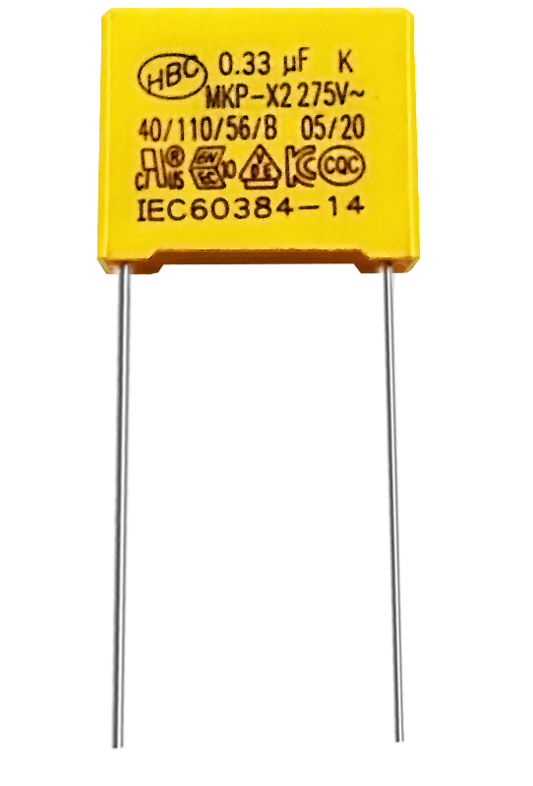

SPECIFICATIONS
Operating Temperature Voltage Rating Capacitance Range Capacitance Tolerance
Package

Insulation Resistance

Dissipation Factor

Voltage Proof
Temperature Humidity

Test Conditions

Capacitance Change
Dissipation Factor

-40℃~+110℃
310VAC
0.0047~10.0μF
±10%(K) standard,
Bulk, Ammo Tape Package
CR≤0.33 μF,I.R≥15,000M2
CR>0.33 μF,I.R≥5,000S (20 ℃,100V,1min)
0.0047μF≤CR≤0.47μF≤0.1%(1KHz,20 ℃)
0.47μF≤CR≤1.0μF≤0.2%(1KHz,20 ℃)
1.0μF≤CR≤10μF≤0.3%(1KHz,20 ℃)
4.3UR DC /5s
Bias(THB)HUMIDITY TEST
Temperature:85 ℃±2 ℃; Humidity:85%±2%
Loading Voltage:240Vac(50Hz/60Hz)
Duration:1000 Hours
≤10% of initially measured value
≤2.5% at 1KHz

APPLICATIONS
Across-the-line EMI filtering and connection in series with the mains for high stability grade applications in severe ambient conditions
For capacitive divider power supply.Such as power meter, LED driver, and other sever ambient condition applications.

Shantou Xin Hua Xiong Electronios Industry Co.,Ltd.
www.cn-huaxiong.com | Tel:【+86】0754-87727171 | QQ:2851010898
E-mail:133269599@qq.com | Fax:【+86】 0754-87728582 | whatsapp:86+15502000092

85℃/85% THB MKP X2 金属化聚丙烯薄膜抑制电源电磁干扰电容器
Metallized Polypropylene Film Interference Suppression Capacitor - JFWT
(85 ℃/ 85 % RH Class X2,Temperature Humidity Bias(THB)Series)

DRAWING:
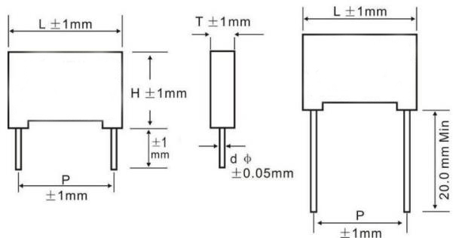
Voltage

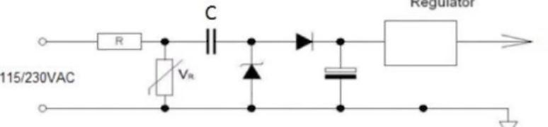
Vdd

Dimensions Table for 310V AC:
(Unit:mm)

 |  |  |  |  |  | Part# Bulk Package(Loose in Box)
CAP | L±1.0 | T±1.0 | H±1.0 | P±1.0 | d Ø±0.05 | standard leads 20mm(+/-1)
0.1 | 18 | 6 | 12 | 15 | 0.8 | JFWTA9104K150000B
0.22 | 18 | 6 | 12 | 15 | 0.8 | JFWTA9224K150000B
0.22 | 18 | 7.5 | 13.5 | 15 | 0.8 | JFWTA9224K150000B01
0.22 | 18 | 8.5 | 14.5 | 15 | 0.8 | JFWTA9224K150000B02
0.33 | 18 | 7.5 | 13.5 | 15 | 0.8 | JFWTA9334K150000B
0.33 | 18 | 8.5 | 14.5 | 15 | 0.8 | JFWTA9334K150000B01
0.33 | 18 | 10 | 16 | 15 | 0.8 | JFWTA9334K150000B02
0.33 | 26.5 | 6 | 15 | 22.5 | 0.8 | JFWTA9334K225000B
0.33 | 26.5 | 7 | 16.5 | 22.5 | 0.8 | JFWTA9334K225000B01
0.33 | 26.5 | 8.5 | 17 | 22.5 | 0.8 | JFWTA9334K225000B02
0.39 | 18 | 8.5 | 14.5 | 15 | 0.8 | JFWTA9394K150000B
0.39 | 18 | 10 | 16 | 15 | 0.8 | JFWTA9394K150000B01
0.39 | 26.5 | 6 | 15 | 22.5 | 0.8 | JFWTA9394K225000B
0.39 | 26.5 | 7 | 16.5 | 22.5 | 0.8 | JFWTA9394K225000B01
0.39 | 26.5 | 8.5 | 17 | 22.5 | 0.8 | JFWTA9394K225000B02
0.47 | 18 | 7.5 | 13.5 | 15 | 0.8 | JFWTA9474K150000B01
0.47 | 18 | 8.5 | 14.5 | 15 | 0.8 | JFWTA9474K150000B
0.47 | 18 | 10 | 16 | 15 | 0.8 | JFWTA9474K150000B02
0.47 | 26.5 | 6 | 15 | 22.5 | 0.8 | JFWTA9474K225000B
0.47 | 26.5 | 7 | 16.5 | 22.5 | 0.8 | JFWTA9474K225000B01
0.47 | 26.5 | 8.5 | 17 | 22.5 | 0.8 | JFWTA9474K225000B02
0.47 | 26.5 | 10 | 19 | 22.5 | 0.8 | JFWTA9474K225000B03
*Please contact us for special item or size not listed.
Please visit our website to get more update data, those data & specification are subject to change without notice.
Shantou Xin Hua Xiong Electronios Industry Co.,Ltd.
www.cn-huaxiong.com | Tel:【+86】0754-87727171 | QQ:2851010898
E-mail:133269599@qq.com | Fax:【+86】 0754-87728582 | whatsapp:86+15502000092

