高压型金属化聚丙烯薄膜电容器
High Voltage Met Polypropylene Film Capacitor- CBB81(PPS)

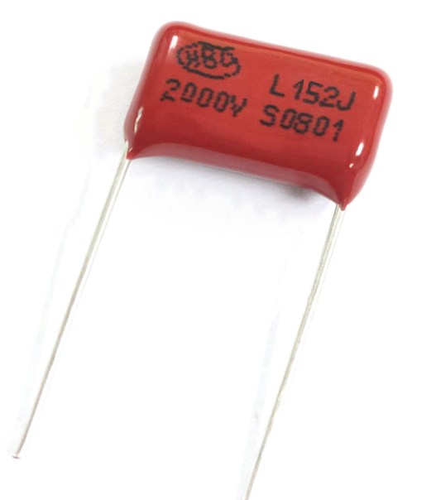
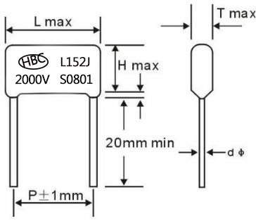
(dφ:0.6mm or 0.8mm)

FEATURES
► Extended foil, flame retardant epoxy coated.
► Ideal for high AC current applications, such as CRT deflection for R-F generators and pulse-forming networks.
► Coated with flame retardant epoxy resin which provides from humidity and mechanical damage.
► Temperature coefficient is negative and variety linear over the operation temperature.

SPECIFICATIONS

Operating Temperature  Rated Voltage  Capacitance Range  Capacitance Tolerance  Dissipation Factor  Insulation Resistance | -40℃~+85℃  1000V,1250V,1600V,2000V.DC 0.001～0.15pF  ±5%,±10%  ≤0.1%(20 ℃,1KHz)  ≥25000MΩ(CR≤0. 1μF),(20 ℃,1min) ≥2000s(CR>0. 1μF),(20 ℃,1min)

STANDARD SIZE(mm)
VDC  Mfd | 1000VDC /1250VDC |  |  |  | 1500VDC /1600VDC |  |  |  | 2000VDC
 | L | T | H | P | L | T | H | P | L | T | H | P
0.00022 |  |  |  |  |  |  |  |  | 19 | 10.5 | 5.5 | 15
0.00047 ～0.00056 | 19 | 7.5 | 12 | 15 | 19 | 7.5 | 12 | 15 | 19 | 7.5 | 12 | 15
0.001 | 19 | 6.4 | 11 | 15 | 19 | 6.4 | 11 | 15 | 19 | 7 | 12.5 | 15
0.0011 |  |  |  |  |  |  |  |  | 19 | 7.5 | 13 | 15
0.0015 | 19 | 7.5 | 12 | 15 | 19 | 7.5 | 12 | 15 | 19 | 8.5 | 13.5 | 15
0.0022 | 19 | 7.5 | 12.5 | 15 | 19 | 7.5 | 12.5 | 15 | 19 | 8.5 | 14 | 15
0.0027 | 19 | 8 | 13 | 15 | 19 | 8 | 13 | 15 | 19 | 9 | 14.5 | 15
0.0033 | 19 | 7.6 | 12 | 15 | 19 | 8.5 | 14 | 15 | 19 | 9 | 16 | 15
 |  |  |  |  |  |  |  |  | 24 | 7.5 | 15 | 20
0.0039 |  |  |  |  | 19 | 9 | 14.5 | 15 | 19 | 9 | 14.5 | 15
0.0047 | 19 | 8 | 13 | 15 | 19 | 9 | 14.8 | 15 | 19 | 9.5 | 16 | 15
 |  |  |  |  | 26 | 8 | 14 | 22.5 | 26 | 8.5 | 14 | 22.5
0.0052 |  |  |  |  | 19 | 9 | 14.8 | 15
0.0056～0.0068 | 19 | 8.5 | 14.5 | 15 | 19 | 10 | 15.7 | 15 | 19 | 10.5 | 17.5 | 15
0.0082 | 19 | 9 | 14.5 | 15 | 19 | 9.5 | 15.5 | 15 | 19 | 11 | 18 | 15
 |  |  |  |  | 26 | 9.5 | 15.5 | 22.5
0.0091 |  |  |  |  | 26 | 9.5 | 15.5 | 22.5
0.0095 |  |  |  |  | 26 | 10 | 16 | 22.5
0.01 | 19.5 | 8.5 | 14 | 15 | 19 | 9.5 | 17 | 15 | 19 | 12 | 19 | 15
 |  |  |  |  |  |  |  |  | 26 | 9.5 | 16.5 | 22.5
0.011～0.012 | 26 | 9 | 15.5 | 22.5 | 26 | 9 | 15.5 | 22.5 | 26 | 10.5 | 18 | 22.5
0.013～0.016 | 19 | 9.5 | 16.8 | 15 | 19 | 11.5 | 18.5 | 15
 | 26 | 9.5 | 16.5 | 22.5 | 26 | 10 | 16 | 22.5 | 26 | 11 | 18.5 | 22.5
0.022 | 19.5 | 10.5 | 15.8 | 15
 | 26 | 10.8 | 18 | 22.5 | 26 | 10.5 | 18.5 | 22.5 | 26 | 13.5 | 20 | 22.5
0.033 | 19 | 13 | 18 | 15
0.047 | 19 | 13.5 | 20.6 | 15
Please visit our website to get more update data, those data & specification are subject to change without notice.
Shantou Xin Hua Xiong Electronios Industry Co.,Ltd.
www.cn-huaxiong.com | Tel:【+86】0754-87727171 | QQ :2851010898
E-mail:133269599@qq.com | Fax:【+86】 0754-87728582 | whatsapp:86+15502000092

