交流电动机运行薄膜电容器 CBB61 -DB61
Exchange film capacitor, motor running CBB61 -DB61
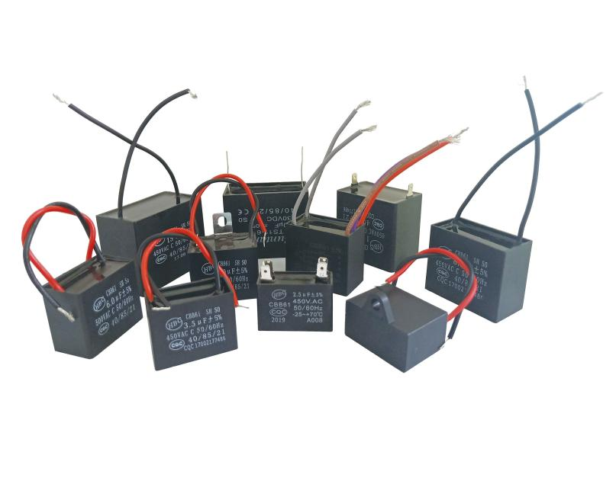
FEATURES
►Electrical apparatus use metalized film with precisely quality control。
►Low D.F.(dissipation factor), lower temperature rise。
►High I.R.(insulation resistance) small size。
►High safety & high reliability。
►Durability and characteristics of frequency, etc。

Shantou Xin Hua Xiong Electronios Industry Co.,Ltd.
www.cn-huaxiong.com | Tel:【+86】0754-87727171 | QQ :2851010898
E-mail:133269599@qq.com | Fax:【+86】 0754-87728582 | whatsapp:86+15502000092
Operating Condition | -40℃~+85℃
Capacitance Range | 1μF～20μF
Capacitance Tolerance | J(±5%)、K(±10%)
Rated Voltage | 250V 400V 450V(AC)
Withstand Voltage | AC≥2UR 2S(Imax≤1.3 InA)
Dissipation Factor | ≤0.003 100Hz
Insulation Resistance | ≥3000S
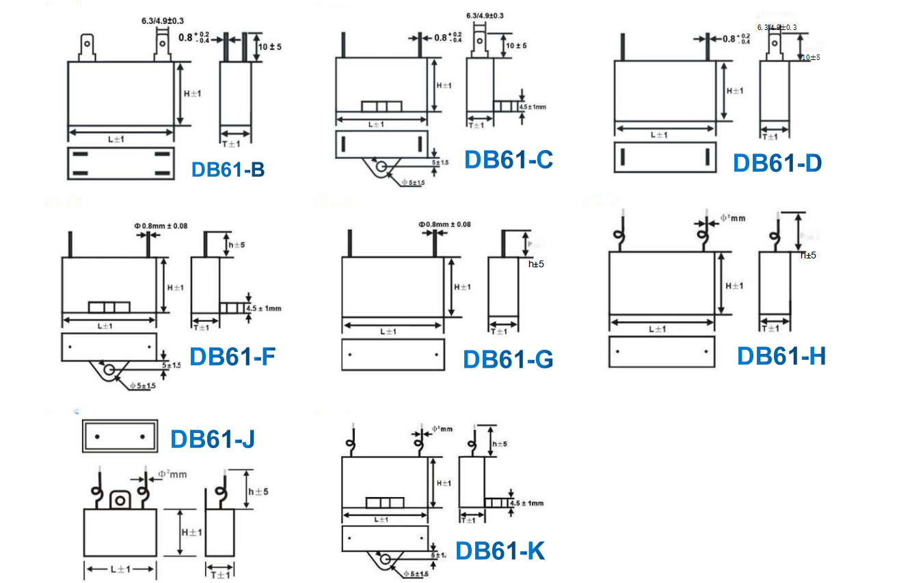
Dimensions For Motor Running Capacitors CBB61
SPECIFICATIONS

 | DB61-C, DB61-F |  |  |  |  |  | DB61-B, DB61-D
 | 250VAC |  |  | 450VAC |  |  | 250VAC |  |  | 450VAC
μF | L | T | H | L | T | H | L | T | H | L | T | H
0.5 | 26.5 | 12.5 | 21 | 26.5 | 12.5 | 21 | 26.5 | 12 | 20 | 25.5 | 12 | 20
1 | 26.5 | 12.5 | 21 | 32 | 14 | 24 | 26.5 | 12 | 20 | 32 | 14 | 25
2 | 32 | 14 | 24 | 37 | 17 | 28 | 32 | 14 | 25 | 37 | 17 | 28
2.5 | 32 | 14 | 24 | 37 | 17 | 28 | 32 | 14 | 25 | 37 | 17 | 28
3 | 32 | 14 | 24 | 38 | 20 | 30 | 32 | 14 | 25 | 38 | 20 | 30
5 | 37 | 17 | 28 | 47 | 20 | 34 | 37 | 17 | 28 | 47 | 20 | 34
6 | 37 | 17 | 28 | 47 | 23 | 34 | 37 | 17 | 28 | 47 | 23 | 34
8 | 47 | 17.5 | 33 | 47 | 28 | 34 | 47 | 18 | 32 | 47 | 28 | 34
10 | 47 | 17.5 | 33 | 47 | 32 | 40 | 47 | 18 | 32 | 47 | 30 | 40
12 | 47 | 23 | 34 | 47 | 32 | 43 | 47 | 23 | 34
15 | 47 | 25 | 34 |  |  |  | 47 | 25 | 34
20 | 47 | 28 | 37 |  |  |  | 47 | 28 | 37

CAP | DB61-G |  |  |  |  |  |  |  | DB61-H
 | 250VAC |  |  |  | 450VAC |  |  |  | 250VAC |  |  | 450VAC
μF | L | T | H | P | L | T | H | P | L | T | H | L | T | H
0.5 | 32 | 10 | 20 | 27.5 | 32 | 10 | 20 | 27.5 | 32 | 10 | 20 | 32 | 10 | 20
1 | 32 | 10 | 20 | 27.5 | 36 | 10 | 20 | 31.5 | 32 | 10 | 20 | 36 | 10 | 20
1.2 | 36 | 10 | 20 | 31.5 | 36 | 11 | 22 | 31.5 | 36 | 10 | 20 | 36 | 11 | 22
1.5 | 36 | 10 | 20 | 31.5 | 36 | 12 | 22 | 31.5 | 36 | 10 | 20 | 36 | 12 | 22
1.8 | 36 | 11 | 22 | 31.5 | 36 | 12 | 22 | 31.5 | 36 | 11 | 22 | 36 | 12 | 22
2 | 36 | 11 | 22 | 31.5 | 37 | 13 | 23 | 31.5 | 36 | 11 | 22 | 37 | 13 | 23
2.5 | 37 | 12 | 21 | 31.5 | 38 | 15 | 25 | 31.5 | 37 | 12 | 21 | 38 | 15 | 25
3 | 37 | 13 | 23 | 31.5 | 38 | 17 | 28 | 31.5 | 37 | 13 | 23 | 38 | 17 | 28
3.5 | 38 | 15 | 25 | 31.5 | 38 | 18.5 | 29 | 31.5 | 38 | 15 | 25 | 38 | 18.5 | 29
4 | 38 | 17 | 28 | 31.5 | 38 | 18.5 | 29 | 31 5 | 38 | 17 | 28 | 38 | 18.5 | 29
4.5 | 38 | 17 | 28 | 31.5 | 38 | 21 | 32 | 31 5 | 38 | 17 | 28 | 38 | 21 | 32
5 | 38 | 18.5 | 29 | 31.5 | 38 | 21 | 32 | 31.5 | 38 | 18.5 | 29 | 38 | 21 | 32
6 | 38 | 19.5 | 31 | 31.5 | 38 | 21 | 32 | 31.5 | 38 | 19.5 | 31 | 38 | 21 | 32
7 | 38 | 21 | 32 | 31.5 | 47 | 23 | 35 | 31 5 | 38 | 21 | 32 | 47 | 23 | 35
8 | 38 | 21 | 32 | 31.5 | 47 | 23 | 35 | 41.5 | 38 | 21 | 32 | 47 | 23 | 35
10 | 47 | 23 | 35 | 41.5 | 47 | 23 | 35 | 41.5 | 47 | 23 | 35 | 47 | 23 | 35
12 | 47 | 23 | 35 | 41.5 | 48 | 33 | 45 | 41.5 | 47 | 23 | 35 | 48 | 33 | 45
15 | 47 | 23 | 35 | 41.5 | 48 | 33 | 45 | 41.5 | 47 | 23 | 35 | 48 | 33 | 45
16 | 47 | 23 | 35 | 41.5 | 57 | 32 | 44 | 51.5 | 47 | 23 | 35 | 57 | 32 | 44
18 | 47 | 23 | 35 | 41.5 | 57 | 32 | 44 | 51.5 | 47 | 23 | 35 | 57 | 32 | 4.4
20 | 48 | 33 | 45 | 41.5 | 57 | 32 | 44 | 51.5 | 48 | 33 | 45 | 57 | 32 | 44

Shantou Xin Hua Xiong Electronios Industry Co.,Ltd.
www.cn-huaxiong.com | Tel:【+86】0754-87727171 | QQ :2851010898
E-mail:133269599@qq.com | Fax:【+86】 0754-87728582 | whatsapp:86+15502000092
交流电动机运行薄膜电容器 CBB61 -DB61
Exchange film capacitor, motor running CBB61 -DB61

CAP | DB61-K
 | 250VAC |  |  | 450VAC
μF | L | T | H | L | T | H
0.5 | 32 | 10 | 20 | 32 | 10 | 20
1.0 | 32 | 10 | 20 | 36 | 10 | 20
1.2 | 36 | 10 | 20 | 36 | 11 | 22
1.5 | 36 | 10 | 20 | 36 | 12 | 22
1.8 | 36 | 11 | 22 | 36 | 12 | 22
2.0 | 36 | 11 | 22 | 37 | 13 | 23
2.5 | 37 | 12 | 21 | 38 | 15 | 25
3.0 | 37 | 13 | 23 | 38 | 17 | 28
3.5 | 38 | 15 | 25 | 38 | 18.5 | 29
4.0 | 38 | 17 | 28 | 38 | 18.5 | 29
4.5 | 38 | 17 | 28 | 38 | 21 | 32
5.0 | 38 | 18.5 | 29 | 38 | 24 | 33
6.0 | 38 | 19.5 | 31 | 38 | 24 | 33
7.0 | 38 | 21 | 32 | 47 | 23 | 35
8.0 | 38 | 24 | 33 | 47 | 26 | 38
10.0 | 47 | 23 | 35 | 47 | 26 | 38
12.0 | 47 | 23 | 35 | 48 | 33 | 45
15.0 | 47 | 26 | 38 | 48 | 33 | 45
16.0 | 47 | 26 | 38 | 57 | 32 | 44
18.0 | 47 | 26 | 38 | 57 | 32 | 44
20.0 | 48 | 33 | 45 | 57 | 32 | 44

Shantou Xin Hua Xiong Electronios Industry Co.,Ltd.
www.cn-huaxiong.com | Tel:【+86】0754-87727171 | QQ :2851010898
E-mail:133269599@qq.com | Fax:【+86】 0754-87728582 | whatsapp:86+15502000092

