降压用盒式金属化聚丙烯薄膜交流电容器
Metallized Polypropylene Film A.C.Capacitor For Capacitive Divider- CBB22A

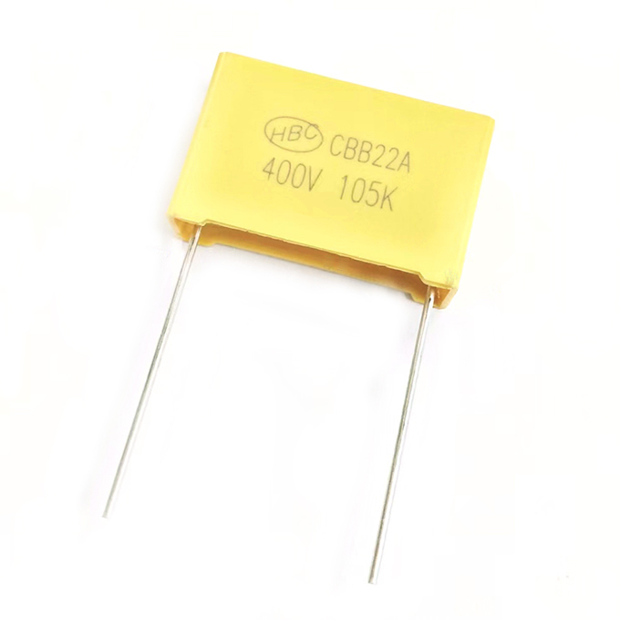

FEATURES
►Metallized polypropylene film, non-inductive wound construction.
►Good self-healing properties, withstanding surge voltage stressing.
►Long stability of capacitance.
►Good properties in damp environment.
►Excellent active and passive flame resistant abilities.

Type Application
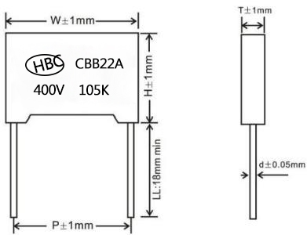
Suitable for applications in serial with the 100~240Vac mains, as energy meter, a small power LED driver module, small household electrical appliances control panel (electric kettle,electric cooker, coffee machine, hair straightener etc.), thermostat, replace the transformer.
Widely used in LC resonant, high frequency high current situation

SPECIFICATIONS

Reference Standard | GB/T14579 (IEC60384-17)
Climatic Category | 40/105/56 B
Rated Temperature | 85℃
Operating Temperature | -40℃~+105℃
Rated Voltage(50/60Hz) | 160Vac | 230Vac | 250Vac | 275Vac/300Vac
Maximum Continuous DC Voltage | 400Vdc |  | 630Vdc
Voltage Proof | 1.6UR(5S)
Capacitance Range | 0.1uF~4.7uF
Capacitance Tolerance | ±5%(J),±10%(K)
Insulation Resistance | IR≥15000MΩ CR≤0.33μF
 | IR≥5000s CR>0.33μF
 | (20℃,100V,1min)
Dissipation Factor | ≤0.1% CR≤0.33μF (20℃,1KHz)  ≤0.2% CR>0.33μF
Note: For long life time and continuous working, please choose 275Vac and upwards voltage.

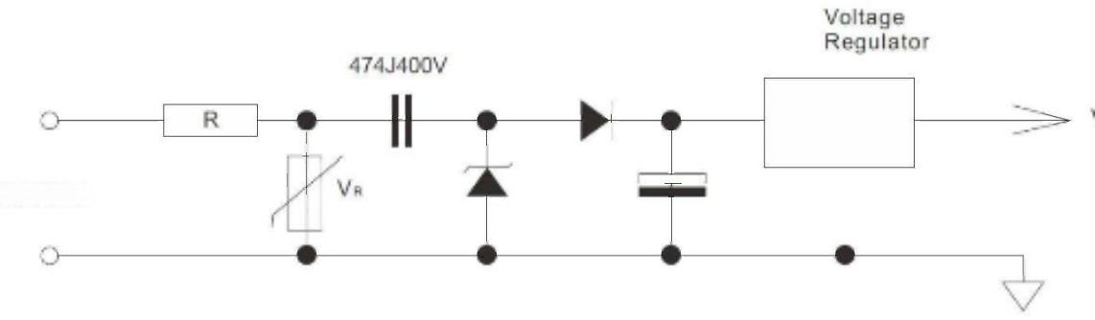
Vdd(vdc)

115/230VAC

Shantou Xin Hua Xiong Electronios Industry Co.,Ltd.
www.cn-huaxiong.com | Tel:【+86】0754-87727171 | QQ :2851010898
E-mail:133269599@qq.com | Fax:【+86】 0754-87728582 | whatsapp:86+15502000092
STANDARD SIZE(mm)
uF | 400VDC |  |  |  |  | 630VDC
 | W | H | T | P | d | W | H | T | P | d
 | ±1.0 | ±1.0 | ±1.0 | ±1.0 | ±0.05 | ±1.0 | ±1.0 | ±1.0 | ±1.0 | ±0.05
0.1 | 18 | 11 | 5 | 15 | 0.6 | 18 | 12 | 6 | 15 | 0.8
 |  |  |  |  |  | 26.5 | 15 | 6 | 22.5 | 0.8
0.12 | 18 | 12 | 6 | 15 | 0.8 | 18 | 13.5 | 8 | 15 | 0.8
 |  |  |  |  |  | 26.5 | 16 | 7 | 22.5 | 0.8
0.15 | 18 | 12 | 6 | 15 | 0.8 | 18 | 13.5 | 7.5 | 15 | 0.8
 |  |  |  |  |  | 26.5 | 17 | 8.5 | 22.5 | 0.8
0.18 | 18 | 12 | 6 | 15 | 0.8 | 18 | 14.5 | 8.5 | 15 | 0.8
 | 26.5 | 15 | 6 | 22.5 | 0.8 | 26.5 | 17 | 8.5 | 22.5 | 0.8
0.22 | 18 | 13.5 | 8 | 15 | 0.8 | 18 | 16 | 10 | 15 | 0.8
 | 26.5 | 15 | 6 | 22.5 | 0.8 | 26.5 | 19 | 10 | 22.5 | 0.8
0.27 | 18 | 13.5 | 8 | 15 | 0.8 | 18 | 16 | 10 | 15 | 0.8
 | 26.5 | 15 | 6 | 22.5 | 0.8 | 26.5 | 22 | 12 | 22.5 | 0.8
0.33 | 26.5 | 15 | 6 | 22.5 | 0.8 | 26.5 | 22 | 12 | 22.5 | 0.8
0.39 | 26.5 | 17 | 7 | 22.5 | 0.8 | 26.5 | 22 | 12 | 22.5 | 0.8
0.47 | 26.5 | 17 | 7 | 22.5 | 0.8 | 26.5 | 19 | 10 | 22.5 | 0.8
0.56 | 26.5 | 17 | 8.5 | 22.5 | 0.8
 | 32 | 20 | 11 | 27.5 | 0.8
0.68 | 26.5 | 19 | 10 | 22.5 | 0.8
 | 32 | 20 | 11 | 27.5 | 0.8
0.82 | 26.5 | 19 | 10 | 22.5 | 0.8
 | 32 | 22 | 13 | 27.5 | 0.8
1.0 | 26.5 | 22 | 12 | 22.5 | 0.8

降压用盒式金属化聚丙烯薄膜交流电容器
Metallized Polypropylene Film A.C.Capacitor For Capacitive Divider- CBB22A

Please visit our website to get more update data, those data & specification are subject to change without notice.

Shantou Xin Hua Xiong Electronios Industry Co.,Ltd.
www.cn-huaxiong.com | Tel:【+86】0754-87727171 | QQ :2851010898
E-mail:133269599@qq.com | Fax:【+86】 0754-87728582 | whatsapp:86+15502000092

