盒式金属化聚酯薄膜电容器
Box Type Met Polyester Film Capacitor- CL21B(MEB)
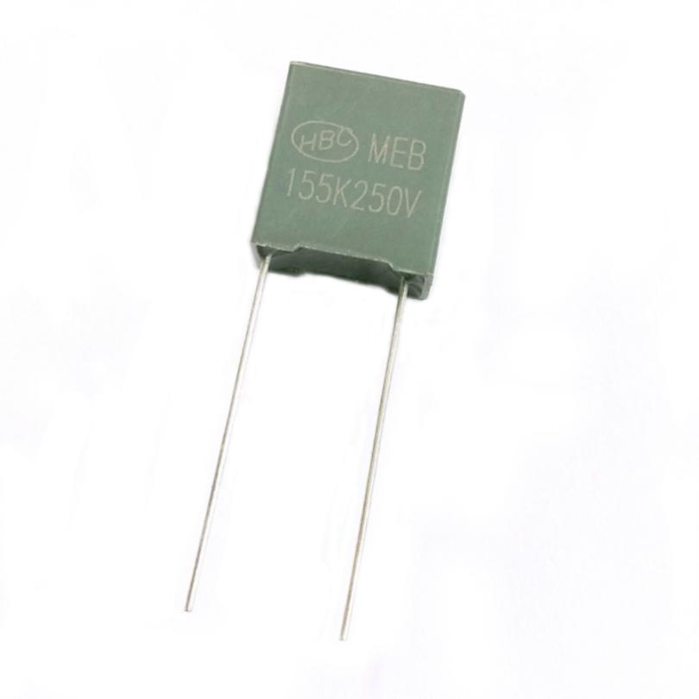
FEATURES
► Non-inductive, plastic case and epoxy resin.
► Box type provides the identical outer appearance.
► High reliability.

SPECIFICATIONS

Reference Standard GB7332(IEC 60384-2)

Operating Temperature Climatic Category Rated Voltage Capacitance Range Capacitance Tolerance Voltage Proof
Insulation Resistance

Dissipation Factor

-40℃~+85℃
40/105/21
63V,100V,160V,250V,400V,630V.DC
0.001～ 2.2μF
±5%,±10%,±20%
1.6UR(5s)

Ur>100V | ≥7500M2,CR≤0.33μF | (20℃,100V,1min)
 | ≥2500s, CR>0.33pF
Uk≤100V | ≥3750M2,CR≤0.33pF | (20℃,10V,1min)
 | ≥1250s, CR>0.33pF

Frequency | CR≤0.1μF | CR>0.1μF
1KHz | ≤1.0% | ≤1.5%

DRAWING

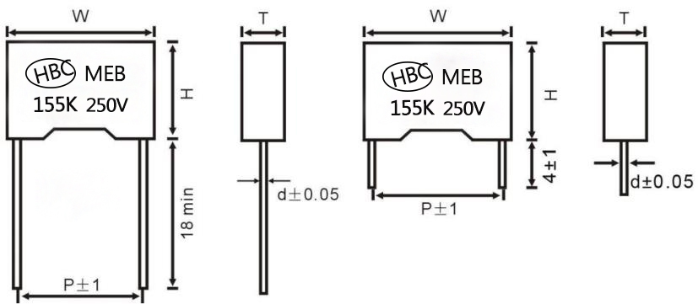

Please visit our website to get more update data, those data & specification are subject to change without notice.
Shantou Xin Hua Xiong Electronios Industry Co.,Ltd.
www.cn-huaxiong.com | Tel:【+86】0754-87727171 | QQ :2851010898
E-mail:133269599@qq.com | Fax:【+86】 0754-87728582 | whatsapp:86+15502000092

盒式金属化聚酯薄膜电容器
Box Type Met Polyester Film Capacitor- CL21B(MEB)
Dimensions( mm)
P:7.5
(Pitch Size)P | 7.5
(Lead Wire Dia.)d±0.05 | 0.6
(Dimension Tolerance: W, H,T) | W±0.5,H±0.5,T±0.5
VDC | 63VDC |  |  |  | 100VDC |  |  |  | 250VDC |  |  |  | 400VDC
Mfd | W | H | T | P | W | H | T | P | W | H | T | P | W | H | T | P
0.0033 | -- | -- | -- | -- | -- | -- | -- | -- | -- | -- | -- | -- | -- | -- | -- | --
0.0047 | -- | -- | -- | -- | -- | -- | -- | -- | -- | -- | -- | -- | -- | -- | -- | --
0.0068 | -- | -- | -- | -- | -- | -- | -- | -- | -- | -- | -- | -- | -- | -- | -- | --
0.01 | -- | -- | -- | -- | -- | -- | -- | -- | -- | -- | -- | -- | -- | -- | -- | --
0.015 | -- | -- | -- | -- | -- | -- | -- | -- | -- | -- | -- | -- | -- | -- | -- | --
0.022 | -- | -- | -- | -- | -- | -- | -- | -- | -- | -- | -- | -- | 10 | 9 | 4 | 7.5
0.033 | -- | -- | -- | -- | -- | -- | -- | -- | 10 | 9 | 4 | 7.5 | 10 | 9 | 4 | 7.5
0.047 | -- | -- | -- | -- | -- | -- | -- | -- | 10 | 9 | 4 | 7.5 | 10 | 9 | 4 | 7.5
0.068 | -- | -- | -- | -- | -- | -- | -- | -- | -- | -- | -- | -- | -- | -- | -- | --
0.1 | -- | -- | -- | -- | 10 | 9 | 4 | 7.5 | 10 | 9 | 4 | 7.5 | 10 | 11 | 5 | 7.5
0.15 | -- | -- | -- | -- | 10 | 9 | 4 | 7.5 | 10 | 11.5 | 6 | 7.5 | -- | -- | -- | --
0.22 | 10 | 9 | 4 | 7.5 | 10 | 9 | 4 | 7.5 | 10 | 15 | 8 | 7.5 | -- | -- | -- | --
0.33 | 10 | 11 | 5 | 7.5 | 10 | 11 | 5 | 7.5 | -- | -- | -- | -- | -- | -- | -- | --
0.47 | 10 | 11.5 | 6 | 7.5 | 10 | 11.5 | 6 | 7.5 | -- | -- | -- | -- | -- | -- | -- | --
0.68 | -- | -- | -- | -- | -- | -- | -- | -- | -- | -- | -- | -- | -- | -- | -- | --
1 | 10 | 15 | 8 | 7.5 | -- | -- | -- | -- | -- | -- | -- | -- | -- | -- | -- | --

P=10.0,15.0
(Pitch Size)P | 10.0 | 15.0
(Lead Wire Dia.)d±0.05 | 0.6 | T≤6,d:0.6 | T>6,d:0.8
(Dimension Tolerance:W, H,T) | W±0.5, H±0.5,T±0.5

VDC  Mfd | 63VDC |  |  |  | 100VDC |  |  |  | 160VDC |  |  |  | 250VDC |  |  |  | 400VDC |  |  |  | 630VDC
 | W | H | T | P | W | H | T | P | w | H | T | P | W | H | T | P | W | H | T | P | W | H | T | P
0.0047 | 13.0 | 9.0 | 4.0 | 10.0 | 13.0 | 9.0 | 4.0 | 10.0 | 13.0 | 9.0 | 4.0 | 10.0 | 13.0 | 9.0 | 4.0 | 10.0 | 13.0 | 9.0 | 4.0 | 10.0 | 13.0 | 9.0 | 4.0 | 10.0
0.0068 | 13.0 | 9.0 | 4.0 | 10.0 | 13.0 | 9.0 | 4.0 | 10.0 | 13.0 | 9.0 | 4.0 | 10.0 | 13.0 | 9.0 | 4.0 | 10.0 | 13.0 | 9.0 | 4.0 | 10.0 | 13.0 | 9.0 | 4.0 | 10.0
0.01 | 13.0 | 9.0 | 4.0 | 10.0 | 13.0 | 9.0 | 4.0 | 10.0 | 13.0 | 9.0 | 4.0 | 10.0 | 13.0 | 9.0 | 4.0 | 10.0 | 13.0 | 11.0 | 5.0 | 10.0 | 13.0 | 90 | 4.0 | 10.0
0.015 | 13.0 | 9.0 | 4.0 | 10.0 | 13.0 | 9.0 | 4.0 | 10.0 | 13.0 | 90 | 4.0 | 10.0 | 13.0 | 9.0 | 4.0 | 10.0 | 13.0 | 9.0 | 4.0 | 10.0 | 13.0 | 9.0 | 4.0 | 10.0
0.022 | 13.0 | 9.0 | 40 | 10.0 | 13.0 | 9.0 | 4.0 | 10.0 | 13.0 | 90 | 4.0 | 10.0 | 13.0 | 9.0 | 4.0 | 10.0 | 13.0 | 9.0 | 4.0 | 10.0 | 13.0 | 9.0 | 4.0 | 10.0
0.033 | 13.0 | 9.0 | 4.0 | 10.0 | 13.0 | 9.0 | 4.0 | 10.0 | 13.0 | 9.0 | 4.0 | 10.0 | 13.0 | 9.0 | 4.0 | 10.0 | 13.0 | 9.0 | 4.0 | 10.0 | 13.0 | 9.0 | 4.0 | 10.0
0.033 | -- | -- | -- | -- | -- | -- | -- | -- | -- | -- | -- | -- | -- | -- | -- | -- | -- | -- | -- | -- | 18.0 | 11.0 | 5.0 | 15.0
0.047 | 13.0 | 9.0 | 4.0 | 10.0 | 13.0 | 9.0 | 4.0 | 10.0 | 13.0 | 9.0 | 4.0 | 10.0 | 13.0 | 11.0 | 5.0 | 10.0 | 18.0 | 11.0 | 5.0 | 15.0 | 18.0 | 11.0 | 5.0 | 15.0
0.068 | 13.0 | 11.0 | 5.0 | 10.0 | 13.0 | 11.0 | 5.0 | 10.0 | 13.0 | 11.0 | 5.0 | 10.0 | 13.0 | 12.0 | 6.0 | 10.0 | 18.0 | 11.0 | 5.0 | 15.0 | 18.0 | 11.0 | 5.0 | 15.0
0.10 | 13.0 | 11.0 | 5.0 | 10.0 | 13.0 | 9.0 | 4.0 | 10.0 | 13.0 | 9.0 | 4.0 | 10.0 | 18.0 | 11.0 | 5.0 | 15.0 | 18.0 | 11.0 | 5.0 | 15.0 | 18.0 | 12.0 | 6.0 | 15.0
0.15 | 13.0 | 11.0 | 5.0 | 10.0 | 13.0 | 9.0 | 4.0 | 10.0 | 13.0 | 11.0 | 5.0 | 10.0 | 18.0 | 11.0 | 5.0 | 15.0 | 18.0 | 11.0 | 5.0 | 15.0 | -- | -- | -- | --
0.22 | 13.0 | 9.0 | 4.0 | 10.0 | 13.0 | 9.0 | 4.0 | 10.0 | 13.0 | 11.0 | 5.0 | 10.0 | 18.0 | 11.0 | 5.0 | 15.0 | -- | -- | -- | -- | -- | -- | -- | --
0.33 | 13.0 | 9.0 | 4.0 | 10.0 | 13.0 | 9.0 | 4.0 | 10.0 | -- | -- | -- | -- | 18.0 | 11.0 | 5.0 | 15.0 | -- | -- | -- | -- | -- | -- | -- | --
0.33 | -- | -- | -- | -- | 18.0 | 11.0 | 5.0 | 15.0 | 18.0 | 11.0 | 5.0 | 15.0 | -- | -- | -- | --
0.47 | 13.0 | 11.0 | 5.0 | 10.0 | 13.0 | 11.0 | 5.0 | 10.0 | -- | -- | -- | -- | -- | -- | -- | -- | -- | -- | -- | -- | -- | -- | -- | --
0.47 | -- | -- | -- | -- | 18.0 | 11.0 | 5.0 | 15.0 | 18.0 | 12.0 | 6.0 | 15.0 | -- | -- | -- | -- | -- | -- | -- | -- | -- | -- | -- | --
0.68 | -- | -- | -- | -- | 18.0 | 11.0 | 5.0 | 15.0 | -- | -- | -- | -- | -- | -- | -- | -- | -- | -- | -- | -- | -- | -- | -- | --
0.68 | 18.0 | 11.0 | 5.0 | 15.0 | 18.0 | 12.0 | 6.0 | 15.0 | 18.0 | 13.5 | 7.5 | 15.0 | -- | -- | -- | -- | -- | -- | -- | -- | -- | -- | -- | --
1.0 | 18.0 | 11.0 | 5.0 | 15.0 | 18.0 | 11.0 | 5.0 | 15.0 | 18.0 | 14.5 | 8.5 | 15.0 | 18.0 | 14.5 | 8.5 | 15.0 | -- | -- | -- | -- | -- | -- | -- | --
1.5 | 18.0 | 12.0 | 6.0 | 15.0 | 18.0 | 15.5 | 9.5 | 15.0 | 18.0 | 15.5 | 9.5 | 15.0 | -- | -- | -- | -- | -- | -- | -- | -- | -- | -- | -- | --
2.2 | 18.0 | 13.5 | 7.5 | 15.0 | 18.0 | 19.0 | 11.0 | 15.0 | 18.0 | 19.0 | 11.0 | 15.0 | 18.0 | 19.0 | 11.0 | 15.0 | -- | -- | -- | -- | -- | -- | -- | --
Please visit our website to get more update data, those data & specification are subject to change without notice.
Shantou Xin Hua Xiong Electronios Industry Co.,Ltd.
www.cn-huaxiong.com | Tel:【+86】0754-87727171 | QQ :2851010898
E-mail:133269599@qq.com | Fax:【+86】 0754-87728582 | whatsapp:86+15502000092

